Knoxville/Oak Ridge Proximity Map

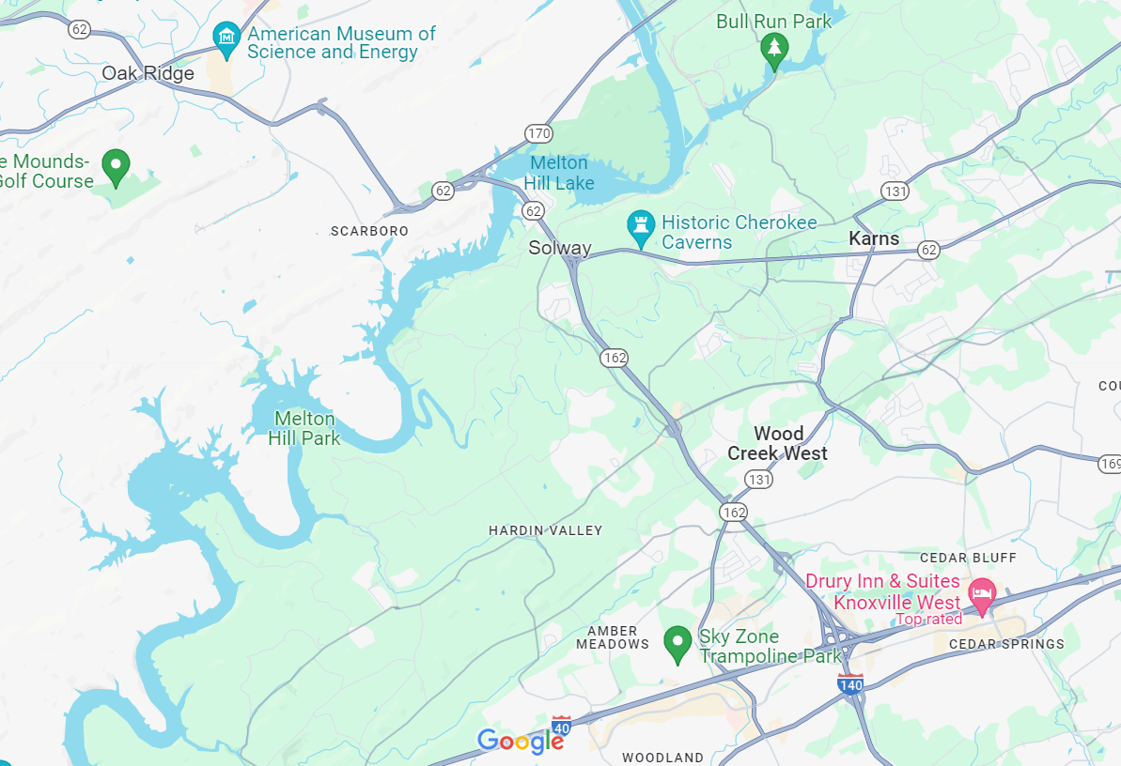



Workshop Location

UCOR Central Campus – Oak Ridge

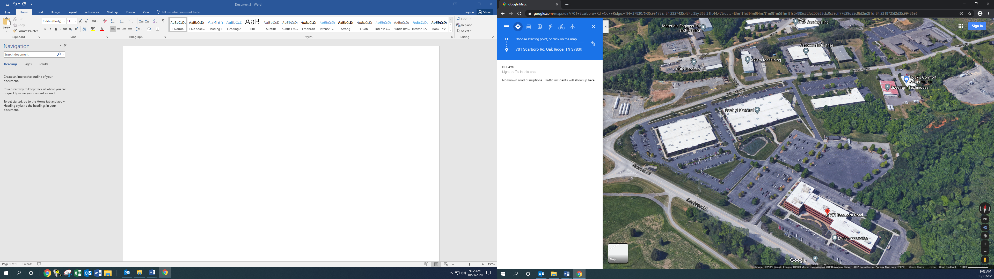

701 Scarboro

102 Union Valley

100 Union Valley

90 Union Valley