EFCOG Contractor Assurance Maturity Model Workshop
Wednesday, May 8 2024
- Recommendations to update the current Maturity Model to be inclusive of both federal and contractor organizations.
- Propose guidance on how to use the Maturity Model to simplify, strengthen and sustain CAS programs.

___________________________________________________________________________________
Draft Introduction: The purpose of this document is to describe the definition and scope for performance assurance that supports project missions. It defines the elements used for performance assurance and how they work to provide the management team with valuable insights into performance such that the signs of declining performance are recognized, to minimize its contribution to accidents, events, and regulatory upsets. Performance assurance not only supports safety and compliance to laws, codes, directives, and standards, but also supports efficient work execution, higher product quality, continuous improvement, and timely product delivery.
This document supplements implementation of DOE O 226.1B, Chg 2.
Discussion: Need to develop guidance on how to use the model

Yellow Highlights indicates requirements that may not be fully addressed in the Maturity Model
Regardless of the performer of the work, the contractor is responsible for complying with the requirements of this Contractor Requirements Document (CRD).
- The contractor is responsible for flowing down the requirements of this CRD to subcontractors at any tier to the extent necessary to ensure the contractor’s compliance with the requirements.
- Contractors must monitor and evaluate all work performed under their contracts, including the work of subcontractors, to ensure work performance meets the applicable requirements for environment, safety, and health, including quality assurance and integrated safety management; safeguards and security; cyber security; business and financial systems; and emergency management.
CAS Management and Scope - Source Requirement (2.a)
"The contractor must establish an assurance system that includes assignment of management responsibilities and accountabilities and provides evidence to assure both the Department of Energy's (DOE) and the contractor's managements that work is being performed safely, securely, and in compliance with all requirements; risks are being identified and managed; and that the systems of control are effective and efficient. "
CAS Effectiveness Validation Source Requirement (2.b)
The contractor assurance system, at a minimum, must include the following:
• (2.b(l)) "A method for validating the effectiveness of assurance system processes. Third party audits, peer reviews, independent assessments, and external certification may be used and integrated into the contractor's assurance system to complement, but not replace, internal assurance systems. "
• (2.b(6)) "Metrics and targets to assess the effectiveness of performance, including benchmarking of key functional areas with other DOE contractors, industry, and research institutions. "
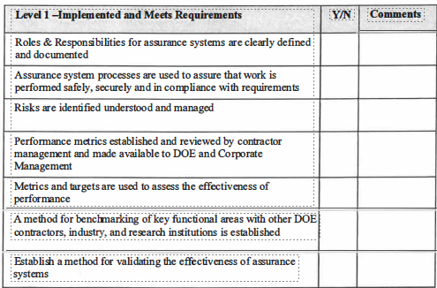

Workshop Notes:
Discussion: Consider adding to meets, flowing down the requirements of this CRD to subcontractors: via their approved quality assurance programs under DOE Order 414.1D to supplement DOE requirements for managing issues.
Discussion: Consider adding to meets, monitor and evaluate all work performed under their contracts, including the work of subcontractors, to ensure work performance meets the applicable requirements for environment, safety, and health, including quality assurance and integrated safety management; safeguards and security; cyber security; business and financial systems; and emergency management.
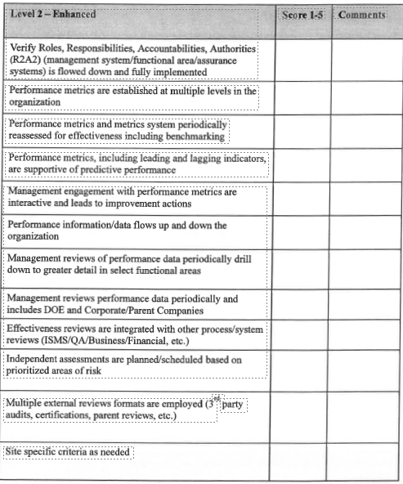
Workshop Notes:
Discussion: Combine enhanced and meets requirement language, includes assignment of management responsibilities and accountabilities
Discussion: Consider adding to enhanced, management routinely participate in field observations as a priority, recognizing the importance of close contact with employees and maintaining operational awareness.
Discussion: Additions to improve inclusivity of both federal and contractor organizations.
Self-Assessment and Feedback- Source Requirement (2.b(2))
"Rigorous, risk-informed, and credible self-assessment and feedback and improvement activities. Assessment programs must be risk-informed, formally described and documented, and appropriately cover potentially high consequence activities. "
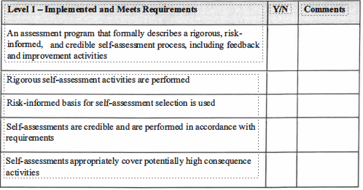

Workshop Notes:
Discussion: Consider adding to meets, Documented assessment procedures identify: process steps, required training, plan development, and documentation. This would move some elements from enhanced to meets.

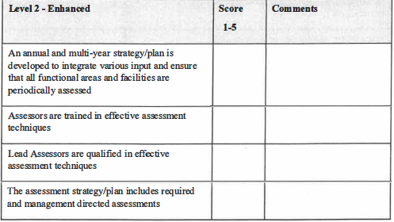

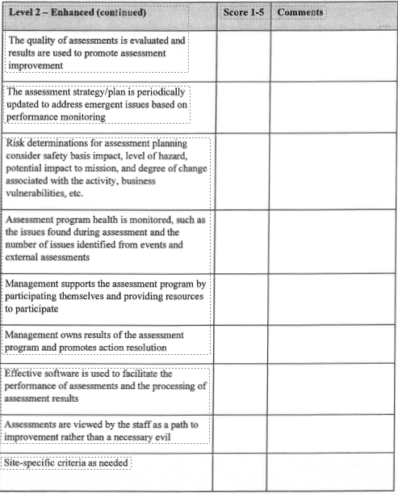

Workshop Notes:
Discussion: Consider adding to enhanced criteria, Assessment plan is informed annually using the Project Risk matrix, operational events and trend information
Discussion: Consider adding to enhanced criteria, periodic self-assessments of the implementation of their issues management procedures improved their performance. Identified as best practice in EA assessment.
Discussion: Consider moving lead assessor qualified in effective assessment techniques to meets section

Discussion: Additions to improve inclusivity of both federal and contractor organizations.

Issues Management- Source Requirement (2.b(3)1 {2.b(3)(a)
■ (2.b(3)) ''A structured issues management system that is formally described and documented and that: "
■ (2.b(3)(a)) "Captures program and performance deficiencies (individually and collectively) in systems that provide for timely reporting, and taking compensatory corrective actions when needed "
Issues Management- Source Requirement (2.b(3)(b))
"Contains an issues management process that is capable of categorizing the significance of findings based on risk and priority and other appropriate factors that enables contractor management to ensure that problems are evaluated and corrected on a timely basis.
For issues categorized as higher significance findings, contractor management must ensure the following activities are completed and documented:
- (2.b(3)(b)(l)) A thorough analysis of the underlying causal/actors is completed;
- (2.b(3)(b)(2)) Timely corrective actions that will address the cause(s) of the findings and prevent recurrence are identified and implemented;
- (2.b(3)(b)(3)) Effectiveness review an effectiveness review is conducted using trained and qualified personnel that can validate the effectiveness of corrective action/plan implementation and results in preventing recurrences; and
- (2.b(3)(b)(4)) Documentation of the analysis process and results
- (2.b(3)(b)(5)) Communicated to Senior Management (Not included here see Performance Analysis)
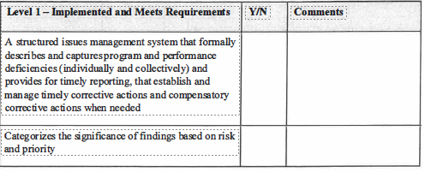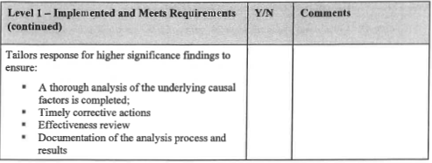
Workshop Notes:
Discussion: Higher significance findings:
- Timely corrective actions will address cause and prevent recurrence
- Effectiveness review using trained and qualified
- Results in preventing recurrence
Discussion: Break out source requirements into single items, and add full source requirement language
- EA assessment weakness, Inadequate or no compensatory actions were documented to ensure that similar issues did not occur while the causes of issues and their corrective actions were identified and implemented
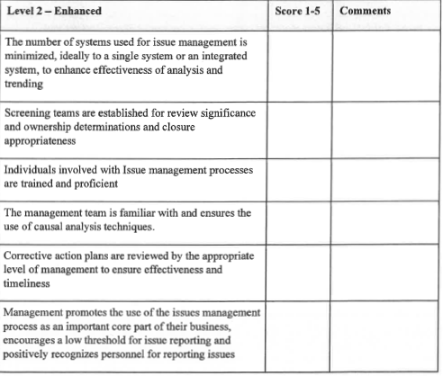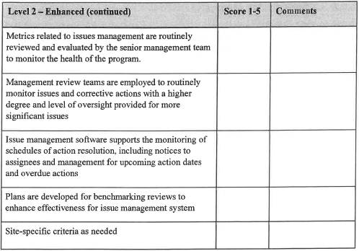
Workshop Notes:
Discussion: Should issue screening be expanded, underscreening was identified as a weakness across the complex: screening team makeup, bias towards underscreening significance.
- EA Assessment Observation: Four contractors incorrectly identified hundreds of noncompliances and deficiencies in meeting nuclear safety requirements as optional opportunities for improvement, lessons learned, or suggestions rather than issues that are required to be resolved. In many cases, no action or untimely action was taken for these issues.
- EA Assessment Observation: Six contractors had not determined the causes to prevent recurrence of 90 structures, systems, and components (SSCs) not being able to perform their function credited in the nuclear facility safety bases.
- EA Assessment Observation: a board of functional area experts assign or review the assigned significance level to ensure consistency.
Discussion: Potential add to enhanced, monitor/assess their categorization processes, enabling them to detect and correct negative trends to ensure that issues are categorized per their procedures.
Discussion: Potential add to enhanced, are working-level (non-supervisory) personnel identifying and inputting issues into the management system. This results in the identification of a broader set of issues for resolution before they can manifest into more severe consequences. Are barriers in place preventing working level personnel from entering issues into system, administrative requirement, training restriction
Discussion: Potential add to enhanced, issues identified during human performance reviews, field observations, and periodic monitoring (via metrics) of performance within contractor organizations (e.g., divisions) or functional areas to be consistently entered into their issues management system.
Discussion: Potential add to enhanced, causal analysis teams develop success criteria for effectiveness reviews documented in the cause analysis to show that actions taken adequately resolve the identified causes.
Discussion: corrective action review boards, staffed by experienced managers, are established to provide quality oversight and feedback on corrective action development, execution and program performance.
Discussion: Additions to improve inclusivity of both federal and contractor organizations.

Feedback & Improvement-Source Requirement (2.b(5))
"Continuous feedback and improvement, including worker feedback mechanisms (e.g., employee concerns programs, telephone hotlines, employee suggestions forms, labor organization input), improvements in work planning and hazard identification activities, and lessons learned programs. "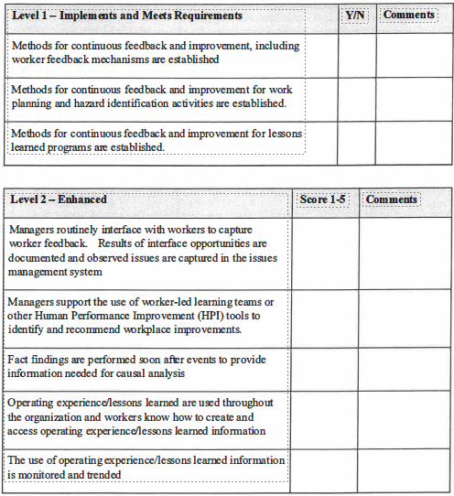 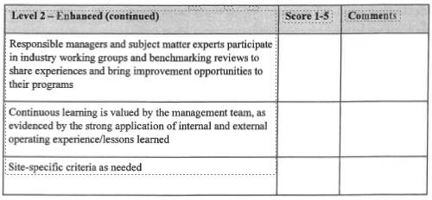
Workshop Notes:
Discussion: Additions to improve inclusivity of both federal and contractor organizations.

Performance Analysis {Communication and Use of Metrics) - Source Requirements(2.b{3)(b)(5) and 2.b.(6))
(2.b(3)(b)(5)) Communicates issues and performance trends or analysis results up the contractor management chain to senior management using a graded approach that considers hazards and risks, and provides sufficient technical basis to allow managers to make informed decisions and correct negative performance/compliance trends before they become significant issues. ''
2.b(6) Metrics and targets to assess the effectiveness of performance, including benchmarking of key functional areas with other DOE contractors, industry, and research institutions.

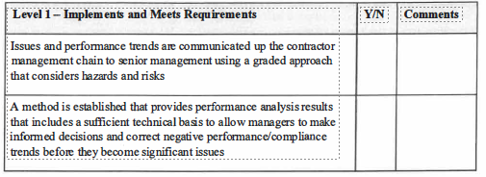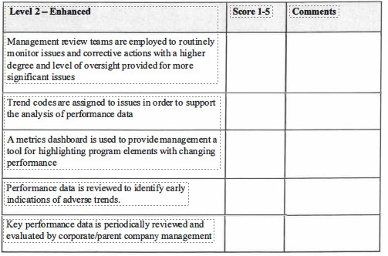
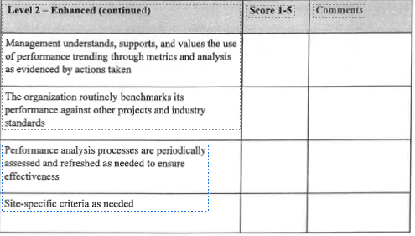
Workshop Notes:
Discussion: Should meets language be expanded, developed processes and have capabilities in their issues management systems that facilitate analyzing issues for trends
Discussion: for addition to enhanced: the manager responsible for the issue to contact the employee identifying the issue (within seven days), if requested by the employee.
Discussion: for addition to enhanced: Trending analysis applies numerical/statistical methods on quantifiable datasets such as event causal codes and project metrics to identify adverse trends.
Discussion: for addition to enhanced: Performance indicators are used to monitor performance of trends after closure.
Discussion: Additions to improve inclusivity of both federal and contractor organizations.
Program Implementation - Source Requirement (2.c)
"The contractor must submit an initial contractor assurance system description to the Contracting Officer for DOE review and approval. That description must clearly define processes, key activities, and accountabilities. An implementation plan that considers and mitigates risks should also be submitted if needed and should encompass all facilities, systems, and organization elements. Once the description is approved, timely notification must be made to the Contracting Officer of significant assurance system changes prior to the changes being made. "
Program Monitoring -Source Requirement (2.d)
"To facilitate appropriate oversight, contractor assurance system data must be documented and readily available to DOE. Results of assurance processes must be analyzed, compiled, and reported to DOE as requested by the Contracting Officer (e.g., in support of contractor evaluation or to support review/approval of corrective action plans)."
Timely Communications - Source Requirement (2.b(4))
Timely and appropriate communication to the Contracting Officer, including electronic access of assurance-related information. "
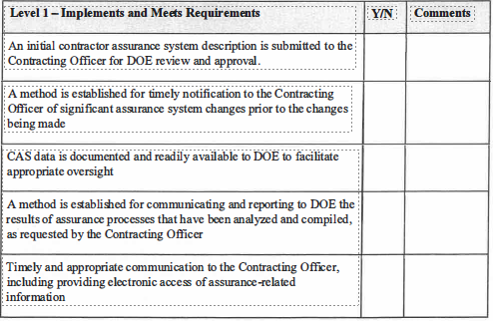
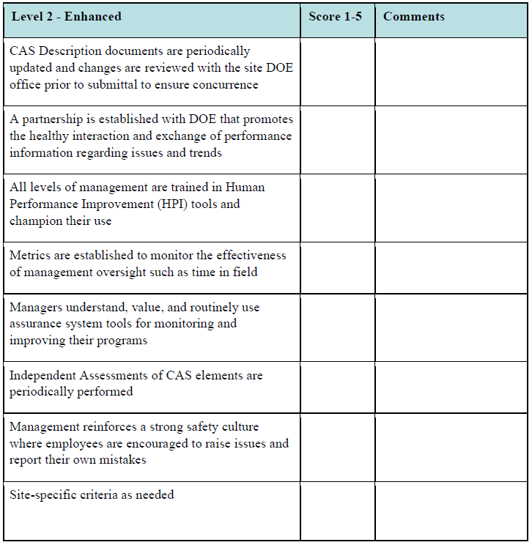
Discussion: Potential to add to enhanced, Reviews of closure documentation by performance assurance personnel led to additional actions resulting in more effective corrective actions and the closure of more issues with supporting documentation. Identified in EA assessment as a strength when implemented.
Discussion: Additions to improve inclusivity of both federal and contractor organizations.

