EFCOG HPI Working Group Monthly Conference Call, September 22, 2022
Participants:
- Mike Petrowski (LANL)
- Lauri Minton (PANTEX/Y-12)
- Sue Baumann (ANL)
- Bill Brown (BNL)
- Gina Fitzmaurice (CNS)
- David Baird (FNAL)
- Brandy Young (INL)
- David Boyce (INL)
- Dan Hammer (INL)
- Tamara Shokes (INL)
- Joe Lockwook (LANL N3B)
- James Newman (LBNL)
- Jeffrey Warga (LLNL)
- Angela McGill (ORCC)
- Benjamine Close (SNL)
- Cheryl MacKenzie (SNL)
- Daryl Smoldt (SRS)
- Douglas McKenzie (SRS)
- Guillame Laforest (PPPL)
- Shalaine Britain (WIPP)
- Lloyd Keith (WRPS)
- Ronda Ruland (SNL)
- Roby Robinson (HLMI)
11:01 meeting started
Mike welcomed everyone and explained the way the HPI share would work for today.
1) Task Team Business
- New/Departing Members
  - Troy Bridges, NREL (interested in joining)

- Team leadership changes
  - Tamara Shokes
    - New Task Team Co-lead

- Review/Update Tasks and initiatives
Human Performance
Activity(s) | Benefit(s) | Deliverable/Key Milestone(s)
ISM-HPI-22-01  ISM-WP&C-22-01  Collaborative effort between HPI and WP&C  Meeting will kick off January 12, 2021.  Team will meet monthly, 2nd Wednesday,  12:00-1:00 EST | BENEFITS id’d in EFCOG Plan  - Integration of HPI into WP&C  - Provide Best Practices/ Guidance that incorporates HPI factors into WP&C practices  GOALS:  - Provide some best practices and techniques to apply for tasks such as Post-Job reviews (After action Reviews), writing techniques to incorporate place keeping, HPI tools, critical steps, etc.  - Align ISM wheel with HPI tools (SRS)  - Emphasize the importance (value added) when HPI is part of WP&C; building resiliency into the process  - Consider - Crosswalk DOE HDBKs  UPDATE: Document is in final review by team members | DELIVERABLE (9/30/2022)  - Generation of guidance for improvement on Pre-Job Briefs, Post Job Reviews, Integrating HPI into job planning. Pause/stop work, etc.  Team  - Mike Petrowski, (LANL)  - Jeffrey Warga, (LLNL)  - William Brown, (BNL)  - Lauren Gagan, (ANL)  - Sue Bauman, (ANL)  - Janes Newman (LBNL)  - Cheryl MacKenzie, (SNL)  - Daryl Smoldt, (SRS)  - Joe Sokolic, (SRS)  - Dennis Cheeks, (SRS)  - Don Barfield, (SRS)  - Bruce Stuart, Amentum  - Daniel Gautier (JLAB)  - Chuck Ramsey, (ORNL)  - Kimberly Jeskie, (ORNL)  - Trish Hughes, (ICP)  - Saprena Lyons, (ICP)  - Brandy Young, (INL)  - Heath Garrison, (NREL)  - Dara Parker, (SNL)  - Janelle Vestal, (SNL)  - Linda Collier, (LANL)
ISM-HPI-22-02  HPI for Knowledge Workers  Kickoff meeting held on December 13, 2021  Team will meet monthly, 2nd Monday,  2:00-3:00 EST | BENEFITS:  - Realize opportunities to break the myth where people believe that HPI does not apply to them as they perform no physical work  UPDATE: The team has completed the brainstorming sessions; came up with a lot of good ideas; currently trying to figure out what we want it to look like; capturing conversations right now, and getting good info out of those. | DELIVERABLE (9/30/2022):  - Issue adaptation for DOE complex from INPO 05-002, Rev 1: Human Performance for Engineers and other Knowledge Workers  Team  - Mike Petrowski, LANL - Facilitator  - Sue Bauman, ANL  - Tamara Shokes, INL  - David Boyce, INL  - Lloyd Keith, WRPS  - Lauri Minton, PANTEX  - Janes Newman, LBNL  - Ben Close, SNL  - Daryl Smoldt & Cassie Sistare, SRS  - Chuck Ramsey, ORNL *(limited participation)
HPI-Task 22-03:  HPI Messaging  Kickoff meeting held on December 1, 2021  Team will meet monthly, 1st Wednesday,  1:00-2:00 EST  Task team members shared lessons and what they are most proud of; Cassie has taken that information and started the document on HPI Messaging; next meeting will share what they have; very productive so far | BENEFITS:  - Getting people to embrace and integrate HPI into daily work.  - Bringing INPO Practices into DOE environment as seek performance improvement  GOALS:  - Provide avenues that may be leveraged to communicate HPI  - Integrating HPI into general business practices to minimize the risk posed by human error  - Educating the workforce about HPI, the benefits of HPI, and opportunities to use HPI  - Gives you the foundation to build reliability into your operations (repeat safe work). At the end of the day it’s not about safety, it’s about performance.  - Opportunities to capture what you do well and where you can do better.  - Make HPI part of the culture so it's second nature  UPDATE: COMPLETE | DELIVERABLE: (9/30/2022)  - Getting people to embrace and integrate HPI into daily work.  - Bringing INPO Practices into DOE environment as seek performance improvement  Team  - Daryl Smolt, SRNS - Facilitator  - Dave Baird, FNL  - Mike Petrowski, LANL  - Cassie Sistare, SRNS  - Paula Pallan, ANL  - Trish Hughes, ICP  - Doug McKenzie, SRS  - Brandy Young, INL  - James Newman, LBNL  - Delwin Allred Lima Technical Services  - Juanita Boddiford, SRMC

- Announcements
  - FY22 Annual Report
    - FY22 Annual Reports due 10-15-2022
    - HPI TT will be supporting ISM Working Group (Time McEvoy and Jim Coy) to develop the FY22 Annual Report
  - FY23 Task Selection
    - Proposed Annual Plans due 10-14-2022
    - Provide subject matter expert feedback to EHSS20 related to the proposed revision to DOE-HDBK-1028-2009, DOE HPI Handbook. DOE is responsible for the final content and editing of the document.
  - EFCOG Safety Working Group (SWG) Reorganization
    - CAS Separated from ISM direct to the SWG
    - New Operations Working Group - Engineering Practices and Nuclear & Facility Safety merged
    - See attached PPT for additional information
Mike mentioned we are needing to do some planning for tasks for FY2023 – asked the team to throw out some ideas:
- Help DOE edit the DOE Handbooks; help Riz Shah; are there sections in the handbook that could be better with today’s knowledge and terminology? Riz has asked industry experts for input, but he will have to figure out what content
- Are there any other tasks the group wants to take on this year?
  - James Newman – how bout some HP Metrics that are meaningful? Mike – we did that a few projects ago, but he will send the information out
  - Angela McGill – emotional intelligence, neuroscience, and how does this fit into HPI; also, Safety II – how does this relate to HPI, renewed focus on what we do right; challenging to get into the metrics on how we quantify what we have done right and how do we present that
  - James Newman – how to support your HPI program, major topic was psychological safety
  - Tamara Shokes – what do we do, or should we do, on what we have done this year? Mike – at fall meeting, do a summary, team got together and this is the takeaway from the project; it’s always a white paper, not a “go do,” it’s information that members can choose to use if they think it works best for their organization
MIKE – PUT IN NOTES – IF YOU HAVE IDEAS ON WHAT CAN HELP THE COMPLEX OR WHAT WE ARE STRUGGLING WITH, LET HIM KNOW NO later than 10/10/2022
- Upcoming Meetings (EFCOG and other HPI meetings)
  - ISM/QA Joint fall meeting
  - November 14-17, 2022
    - Monday will be task team leads reporting out;
    - Tuesday morning will be the QA Joint meeting day.
    - Tuesday afternoon thru Thursday will be individual task team breakout sessons (we typically hold HPI TT on Thursday so you can attend the other groups if you are on multiple teams)
  - https://efcog.org/events/qa-ism-fall-2022-meeting/
  - Registration is OPEN: https://efcog.regfox.com/qa-ism-fall-2022-meeting
  - Virtual
  - Looking for presenters
  - Discuss/report on FY22 task results
  - Looking for a host for the Spring meeting (in-person)

- Webinars: still the same
  - Paradigm Human Performance ltd + Shane Bush
    - www.paradigmhp.com
    - Every OTHER Thursday 2:00 PM GMT – Most recent this morning, 9/22
      - Deepwater Horizon Learning Team, facilitated by Bob Moschetta
      - POC - Teresa Swinton: webinar@paradigmhp.com
      - Registration: https://www.paradigmhp.com/learning-organisation-webinar
      - NEW NAME for Webcast library: HOP Academy
      - There is a whole library of content you can access
    - Human Performance course (https://bushcohpi.com/)
    - University of Idaho 3-day Human Performance Improvement Practitioner Certificate Course (CEUs)
      - Oct. 11th to 13th, 2022 ONLINE: Now Registering
    - University of Idaho 3-day Human Performance Improvement Practitioner Certificate Course (CEUs)
      - Oct. 25th to 27th, 2022 LIVE in Las Vegas: Now Registering
    - Advanced University of Idaho 3-day Human Performance Improvement TECHNOLOGIST Certificate Course (CEUs)
      - Nov. 15th to 17th, 2022 LIVE in Las Vegas: Now Registering
  - EUCI - Human Performance Community of Practice
    - https://www.resilientgrid.com/hpcop
    - Hosted by KnowledgeVine
    - Every other Thursday 4PM EST – Next one is TODAY 9/22
      - Pamela Ey, Ph.D., Decision Making in the Wild
      - We are excited to learn more about Naturalistic Decision Making, the study of how people make important decisions in the real world, often with incomplete information, time pressure, and extreme consequences
    - HP Community of Practice discussions will continue to take place every other Thursday and are free for the HP community to participate. There will be a presentation and discussion by a few select hosts, followed by a question and answer/discussion period for all. We will follow up on the session with a virtual Happy Hour.
    - To join: https://mailchi.mp/e4274b7f9e84/hpcop
    - HumanPerformanceCOP@gmail.com
    - Past Presentations: https://www.resilientgrid.com/hpcop-3

  - CHOL - Community of Human and Organizational Learning
    - Formerly HPRCT
    - https://www.cholearning.org/
    - https://hprct.org redirects you to the new webpage
    - Monthly Webinars:
      - https://www.cholearning.org/professional-development
      - Upcoming Webinar:
        - September 22, 2022
        - EVA 23: Lessons Learned from a NASA Spacewalking Close Call
        - Chris Hansen will present NASA's lessons learned from EVA 23.
    - News and Blogs:
      - https://www.cholearning.org/news
    - Video Library:
      - https://www.youtube.com/channel/UCRbkD3m2ro7kCK-uF1X772A
    - 2022 Conference Materials Access
      - Ticket holders have exclusive access to recordings and presentations.
      - Utilize your Sched login right here on our website.
      - Material will be publically available sometime this fall
    - 29th Annual Conference (2023)
      - Renaissance Portsmouth-Norfolk Waterfront Hotel in Portsmouth, VA
      - Conference: Tuesday, June 13th thru Thursday, June 15th Workshops: Monday June 12th and Friday, June 16th
      - Conference Mailing List (https://www.cholearning.org/professional-development)

  - Jake Mazulewicz, Ph.D. (JMA Human Reliability Strategies, LLC)
    - Register here —> https://reliableorg.us17.list-manage.com/track/click?u=69375436f0fe7417b32098519&id=495d22c022&e=450c586b2d
2) HPI Share
Joe Lockwood, N3B Los Alamos
Person View Vs. System View with a short case study example.
Joe discussed the JMA HPI Handbook for Leaders (www.reliableorg.com). They can be purchased online.
As Joe read through the pocket handbook, he realized the personal view vs. system view is meaningful in the types of work we do. He has an 8-hour HPI training they do for everyone, not just for supervisors; it’s set up for teams to work with their managers/supervisors in the class.
True/False statements poll. These are NOT absolute statements.
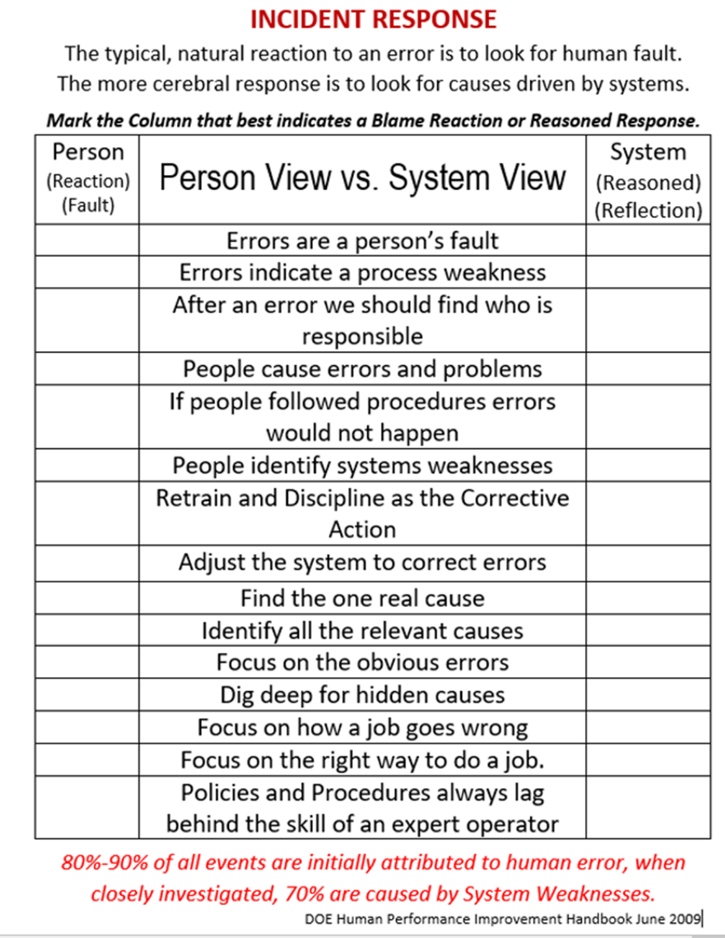
Go through the list of true/false statements. “Opinions are just that – OPINIONS. They are not facts, so let them go.” Slide
We have to shift our thinking from “WHO failed” to “WHAT failed.”
(Person View vs. System View table)
Breakout sessions went over the Person View vs. System view DLA
Breakout Team 1: the last one – most impactful conversation; the target level you write the procedures at, you may ???? – expert based systems compared to what we believe “normal” is, where we should write the procedure for the newest person to the org. When we are writing the4 procedure, we go talk to the operator because we value them; “if people follow procedures, errors would not happen” is a person view because you are assuming the procedure is perfect, and you are not listening to the folks, just assuming you’ll be fine
Breakout Team 2: one real cause vs all the relvant causes; they have seen a person-centric view taken, when there are multiple causes that are person-focused, with one true cause being system view; “Root cause,” people get into the mindset of looking for one true cause when there are usually many
Breakout Team 3: talked about focus on how a job goes wrong vs. how a job goes right; what does good look like; how our organizations focus on what went wrong; we are driven by our requirements, management, oversight, to focus on what went wrong; discussion on debriefing what went well after a job; what is happening before the job goes right – touched on digging deeper for hidden causes, obvious vs. deep digs; people create safety
Breakout Team 4: focusing on the obvious errors; usually you discover an issue by a person’s action – that can uncover system failures; they discussed that the person’s actions are pretty straightforward, it’s harder to find the system issues that caused that human action; you could discover system failures when you focus on the obvious; we always start at the obvious, but we don’t want to stop there – ask past the person view.
Breakout Team 5: one team felt like some of the statements could apply to both; Joe said they do that in the training sometimes – it’s not about memorizing the right answer, it’s about using their brain to think deeper; sometimes people can convince him one way or another, and he appreciates that people are thinking and discussing it; e.g., “people identify system weaknesses” could apply to both; retrain and discipline – if that’s your go-to action, there’s a problem – it is sometimes the answer, but depeding on how you’re using it, it could be person or system based; being forced to discipline someone for an honest error undermines HPI
Joe said they are using this to get people to start thinking differently. People who are not familiar with this always struggle with this exercise; it gets them thinking.
The importance of this came about during a safety champion spotlight (recognition program); she recognized an issue with a safety assembly area where there was natural debris covering the parking lot and curb; she identified it, they fixed it, and made notable improvements. About half of the people said it was a shoe isuse – the person who was wearing pump shoes had problems walking around, so she should have worn better shoes (they aren’t wrong, but); the other half recognized it as a system problem, because the walking surface was not safe. People were angry and adamant about the person view. It creates such emotion, vs. system view really fixes things and takes a lot of the emotion out of it.
Question: was the reason why the area was the way it was, was that addressed – you can do cleanups, but how did it get to that point, and does some kind of maintenance happen? Joe said they have created a sense of intolerance of hazardous conditions, and should not be acceptable.
People pay attention to what the organization does. Reactions matter.
“How mgmt reponds to failure tells you everything you need to know about culture (or something like that) - Todd Conklin” (from Bill Brown)

3) Roundtable
- Mike Petrowski (LANL)
  - One executive staff member is tasked with improving the work planning and control process at the lab
    - Mike will be reaching our to several team members to benchmark WP&C and HPI integration
  - Learning Team Facilitator Orientation going well helping people learn about learning teams and how to facilitate
  - Two Books to recommend:
    - The Practice of Learning Teams: Learning and improving safety, quality and operational excellence, by Mr Brent L Sutton (Author), Mrs Glynis McCarthy (Author), Mr Brent M Robinson (Author), Mr Brent Sutton (Author), Dr Todd E Conklin PhD (Foreword)
      - https://www.learningteamsbook.com/
    - Understanding Mental Models: Practically Applying Performance Modes, Systems 1&2, and GEMS, by Rob Fisher (Author)
- Lauri Minton (PANTEX/Y-12) – spent the week at Y-12 teaching CNS HPI for Managers and Supervisors, and developing an Intro to HPI for Utilities Management; been doing a lot of training lately now that travel restrictions for Covid have been lifted. Discussing FY2023 goals for HPI team now with management
- Joe Lockwood (LANL N3B) – gave an excellent presentation today!
- Lloyd Keith – not much new, but teaching a lot of classes, lots of new people coming in, some are seeing HPI for the first time; have had some interesting interactions with some of those folks
- James Newman – been on a causal analysis team; person did something that some call a violation, some think it was just drift from what was expected; so the conversation today is very timely. There is a lot of blame on the person, no a system view – some see it as an anomalous issue. An employee put his finger in a pinch point and it got pinched. They are looking at more system-related view, but evem people who look at system view a lot still fall into person view – great activity for things going on a lot lately.
- Jeff Warga – just had working group meeting yesterday; deployed the idea of task teams borrowing off the EFCOG model. One team objective was benchmarking with other DOE contractors as well as corporate learning about management engagement, but one specific question was about HPI. May be able to use that information to stand up an HPI/HOP program at the lab. They still have an active task team to evaluate how they are integrating HPI tools into their institutional work planning and control program. Doesn’t want to sound like he is boasting, but would be happy to share once they are done with that. New task team they are standing up (historically a grass-roots volunteer program) – at this different era of HPI, HOP, resources, ideas – they are looking at the levels of HPI training and what roles they play. Stood up a final team tasked with collecting HPI-topic videos; trying to grab anything and everything they can find to use for HPI videos. Welcomes any input from anyone in this group – eventually want to put a gateway link where they can communicate and people can use the links for a standup briefing.
MIKE WILL SEND OUT VIDEO LIST WHEN HE SENDS OUT THE MEETING MINUTES
- Dave Baird – one large change and one smaller one – at the lab, they have created a position called “Events Response Program Manager” that is a new position, internal, filled and the individual is leading an effort to create a new procedure at the lab that is going to combine with a database, all the events at the laboratory will funnel through the overarching procedure and database. Trainign program is the other one – for the laboratory for those individuals who will be doing reviews using HPI principles; used to have a vast database in the past, and have done a good job of mentoring, but this program will bridge the gap. The writeup he promised to send Mike follows:
Fermilab is in the midst of updating it’s incident review program. The new “Event Response” Program includes a internally-hired program manager, a written program and an integrated overarching database that incorporates CAIRS events, reviews with HPI Principles, and ORPS/NTS events. Other updates related to Fermilab’s HPI Program include the development of a draft training course for lead reviewers using HPI Principles. Once completed, the draft training content will be sent to the lab’s Human Resources Training Group for course development. The self-guided training course will be highly-interactive and contain both knowledge checks and a test.
- Shalaine Britian - ConOps/HPI completed human performance benchmarking at INL. Huge thank you and shout out to Tyson Allen and his wonderful team for their hospitality and taking time to share their expertise. We have briefed senior management and have started implementing several processes we observed while there. I was able to use their critique report on Tuesday to capture additional information following our Event Learning Review (fact finding). We also have managers starting to use the term “resiliency”. It’s a great move in the right direction!
- Angie McGill - I have been spending the majority of my HPI-related task work in training of new hires on HPI Overview & Tools. Training is very well-received and “end-of-course” forms indicate good engagement and appreciation for the HPI concepts and tools.
Mike will be sending out a request for the virtual fall meeting, or ideas for people who might want to present that we can ask.
The next EFCOG HPI Task Team meeting is Thursday, October 20, 2022
Meeting concluded 11:15 CDT

