EFCOG HPI Community of Practice Monthly Conference Call
December 21, 2023
Meeting started at 11:00 CST.
Participants:
- Mike Petrowski (LANL)
- Ken Madson (LANL)
- Lauri Minton (PANTEX)
- Mark Shadix (CNS)
- Lauren Clements (CNS)
- Barbara Jesus (LLNL)
- BJ Deets (SRS)
- Daryl Smoldt (SRS)
- Fred Gholson (INL)
- Brandy Young (INL)
- David Boyce (INL)
- Tamara Shokes (INL)
- Dré Layson (IEC)
- Jay Poole (ORNL)
- Nancy Van Wermeskerken (PPPL)
- Roby Robinson (Hanford)
- Joe Esty, Jr. (LUCAS)
- Lloyd Keith (LUCAS)
- Harri Emari (SLAC)
- Eric Schlatter (FNAL)
- Angela Aparicio (FNAL)
- Amanda Jimenez (SPA)
- James Newman (LBNL)
- Tim Snow (NREL)
- Valerie Webb Kline (SANDIA)
- Linda Flores (SANDIA)
- Matt Pope (WCS)

Welcome new member, Eric Schlatter
1) Community of Practice Business
- Review/Update Tasks and initiatives
  - ISM-HPI-24-01 - Support DOE with the revision of HPI DOE-HDBK-2009-1028
  - ISM-HPI-24-02 - Support CAS WG with EFCOG SAFETY SUBGROUP ISM/CAS/QA TASK 3 - Establishing a consistent approach to addressing improvement in operational performance.
  - ISM-HPI-24-02 - Support Office of ES&H Reporting & Analysis, EHSS-23, with Revision of DOE-STD-1197- Occurrence Reporting Causal Analysis
- Challenges – none
- Other updates –
  - New Team members
Eric Schlatter
Event Review and Analysis Lead
Fermi National Accelerator Laboratory (FNAL)
630.840.5264
eschlatt@fnal.gov

Human Performance
Activity(s)  ISM-HPI-24-01 | Benefit(s) | Deliverable/Key Milestone(s)
Support EHSS-20 revision of DOE-HDBK-1028-2009, Human Performance Improvement Handbook | Human Performance Tools for Individuals,  Work Teams, and Management were written in June 2009. They have become thecore reference documents for many users both within and outside the DOE complex. These updates will help expand the scope of the Department's HPI programs by encompassing Human and Organizational Performance (HOP)  This effort will result in significant revisions to the Handbooks, with an estimated twenty-five percent change to Volume 1 and a fifty percent change to Volume 2. The content and the approach to the topics will be based on concepts and practices found helpful in the commercial nuclear power industry, electrical grid and distribution, national laboratories, and those adopted by other sectors. | The EFCOG HPI Task Team will collaborate with EHSS-20 to select EFCOG team members.  EHSS-20 will identify the specific updates that will be made by the team revising the Handbooks. The team will be composed of a Federal Project Lead with academic and technical experts. Team members will include subject-matter experts from DOE M&O contractors and thought leaders from outside the DOE complex.
Task 23-01 update:
- Team Leads have submitted DRAFT documents; documents have been published for the teams to review and provide additional comments.
- Chapter teams worked independently, then shared with Kalen Ortiz, who is the project manager for the project; Kalen has put the cleaned-up documents on a shared drive for people to go review and comment. The comment phase ends December 31, 2023.
- Currently in the final comments and feedback, Participants have until December 31 to submit comments, then resolving phase – next meeting is in March 2024.
- If you have any questions, please email Kalen Ortiz at Kortiz@projectenhancement.com

Status Update:
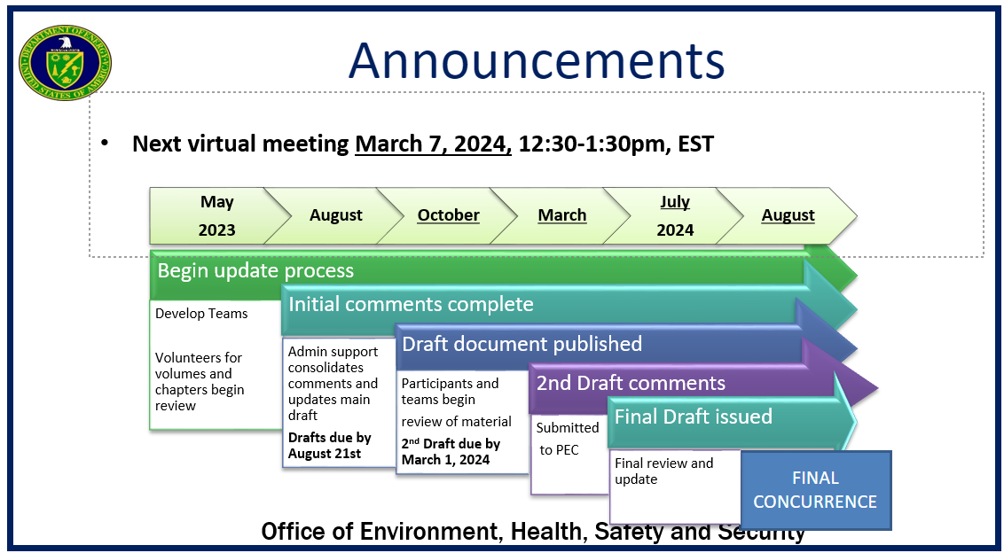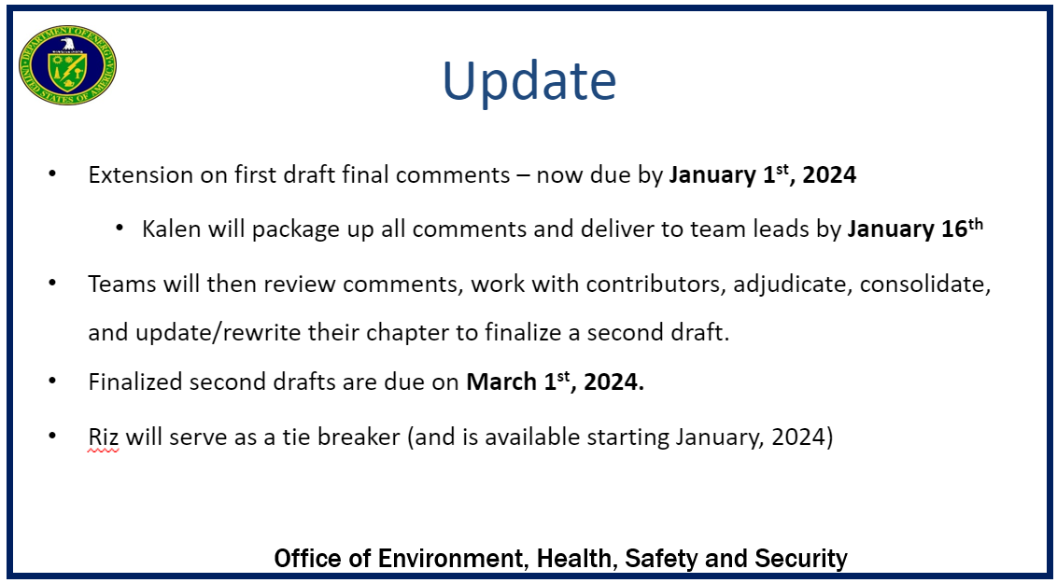
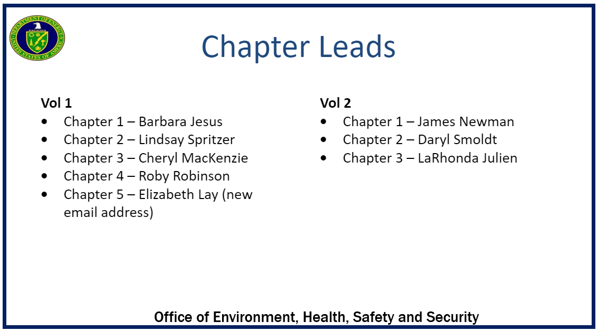

Human Performance
Activity(s) | Benefit(s) | Deliverable/Key Milestone(s)
ISM-HPI-24-02-  EFCOG SAFETY SUBGROUP ISM/CAS/QA TASK 3  ESTABLISHING A CONSISTENT APPROACH TO ADDRESSING IMPROVEMENT IN OPERATIONIAL PERFORMANCE  WP-SAF-ISM-CAS-QA-001-RA | HIP element: Incorporate HPI tools and principles in CAS WG activity.  CAS Element: Establish a standard process to support Disciplined Operations language that will be included as part of a Prime Contractors Performance Measure related to disciplined operations.  Objective 6.5 – Demonstrate improvement in formality and rigor for Organizational Culture in Conduct of Operations through the institutional implementation of effective and efficient counter measures. This includes improved safety culture, safety conscious work environment, measuring and monitoring to show improvements, supervisory involvement, improvements in training, and working towards a learning organization. | The EFCOG CAS Working Group will collaborate with EFCOG team members to create a White Paper.
Status Update:
Norm Barker is the CAS WG lead for this task.
Working with CAS on an Operational Standard for Disciplined Operations language.
Norm gave an update at the Fall EFCOG ISM/QA/CAS meeting

Human Performance
Activity(s) | Benefit(s) | Deliverable/Key Milestone(s)
ISM-HPI-24-03- Continue HPI CoP technical support of Office of ES&H Reporting & Analysis, EHSS-23, Revision of DOE-STD-1197-2011, Causal Analysis | HPI element: Support the enhancement of the Causal Analysis process  HPI concepts and principles integrated into Revision of DOE-STD-1197- Occurrence Reporting Causal Analysis) | DOE-STD-1197- Occurrence Reporting Causal Analysis) revision that includes HPI perspective.
Status Update:
Andy Hobbs is HPI CoP team member for this task.
Andy Hobbs is deeply involved with this and taking into consideration the human element and how humans approach work; may see a major revision on the A3 nodes – they’re making sure the interfaces with the other nodes still make sense.
A big thank you to Andy Hobbs who has supported many meetings and gotten deep into this effort.

- Upcoming Meetings and Conferences (EFCOG and other HPI meetings)
  - EFCOG Spring 2024 QA/ISM/CAS Joint meeting
    - Proposed for May 6-9, 2024 – tentatively scheduled – looking at doing a live (or hybrid) meeting in the Spring
    - INL tentatively hosting
    - Save the date on your calendars!
  - Human Performance In Action (HPAC)
    - April 15th-17th, 2024 at Harrah's New Orleans Hotel!
    - https://www.humanperformanceinaction.com/
    - Registration details: https://www.humanperformanceinaction.com/learn-more
  - Community of Human and Organizational Learning (CHOL)
    - 2023 Conference:
      - General session recordings are now available to ticket holders. Recordings are accessed through the Sched App. Navigate to the session you want to watch, click for more information, and navigate to the video stream button. We ask that you do not share these recordings with anyone.
      - The general public can view the recordings beginning on January 1st, 2024.
    - 2024 Conference:
      - June 11-13, 2024 | Workshops June 10 & 14, 2024
      - Hilton Lake Las Vegas, Henderson, NV
      - Event website: https://www.cholearning.org/2024learningconference
      - Buy Tickets: https://www.eventbrite.com/e/impact-2024-cholearning-30th-annual-conference-registration-771675250447?aff=Website
      - Now accepting speaker applications for the 2024 Learning Conference. https://www.cholearning.org/call-for-presenters
- Webinars: still the same
  - EUCI - Human Performance Community of Practice
    - https://www.resilientgrid.com/hpcop
    - Hosted by KnowledgeVine
    - Next meeting is December 21
    - HP Community of Practice discussions will continue to take place every third Thursday and are free for the HP community to participate. There will be a presentation and discussion by a few select hosts, followed by a question and answer/discussion period for all. We will follow up on the session with a virtual Happy Hour.
    - To join: https://mailchi.mp/e4274b7f9e84/hpcop
    - HumanPerformanceCOP@gmail.com
    - Past Presentations: https://www.resilientgrid.com/hpcop-3
  - CHOL - Community of Human and Organizational Learning
    - Formerly HPRCT
    - https://www.cholearning.org/
    - https://hprct.org redirects you to the new webpage
    - Monthly Webinars:
      - https://www.cholearning.org/professional-development
      - Jan 24, 2024, 11:00 AM – 12:00 PM EST: Avoiding HOP Deployment Errors https://www.cholearning.org/events/avoiding-hop-deployment-errors
    - News and Blogs:
      - https://www.cholearning.org/news
    - Video Library:
      - https://www.youtube.com/channel/UCRbkD3m2ro7kCK-uF1X772A
    - Ask the Community
      - Our online interactive forum is now LIVE! Check-in back daily for insider access to Conference insights.
      - https://www.cholearning.org/askthecommunity
  - Paradigm HPI (HOP Academy)
    - Monthly Mind the Gap Webinars:
      - https://www.paradigmhp.com/webinar
      - Email contactus@paradigmhp.com to sign up for the webinars.
      - Webinars on the FIRST Thursday of each month
        - February 2, 2024 at 3:00pm (BST) via Zoom.
- PodCasts:
  - Pre-accident Investigation Podcast w Todd Conklin
  - The Safety of Work w David Provan
  - A HOP Podcast with No Name w Adrea Baker and Matt Florio
  - Health and Safety Conversations w Tim Bourne
  - Safety on Tap w Adrew Barrett
  - The HOP Nerd w Sam Goodman
  - Safety Labs w SLICE
  - Leading Safely Podcast w Georgina Poole
  - Rebranding Safety w James MacPherson 10. Psych Health and Safety w Peter Kelly
  - Amy Edmondson: How To Fail Well

2) HPI Share:
Holiday HPI – Mike Petrowski
Everyone has a LOT going on this time of year; Mike presented a share on how to help people stay focused amidst the distractions (see presentation)
3) Round Table (Those who provided updates)
- Mike Petrowski & Ken Madson (LANL) – continuing the journey; still doing LT’s and HPI training
- Ken – just been more involved in LT’s and meeting more people at the Lab – making headway; wrapping up the year – people on va
- Lauri – benchmarked SNL and LANL – really good ideas
- Batbara Jesus (LLNL) – Lucas Engineering training them on some HOP – 3rd time to have them there in the last few months sharing HOP message with their folks
- BJ Deets (SRS) – nothing to report
- Daryl Smoldt – SRMC side (Mission Completion) – rolled out HPI DLAs with Operations in October; went really well, well-received; have been directed to expand that into other work groups (maintenance, rad protection, others); have a plan/calendar to suppor6t that weekly through September of 2024; also have started development of ConOps and HPI short-focus videos; BJ is doing the video side, but will add those to the SharePoint site; SRNS is transitioning to a new program manager; BJ been filling that role for several months, but will have a new program manager starting on 1/2/24
David Boyce asked if Daryl could give us an overview of DLA’s
Few dozen in a SharePoint library; 3 are built around a snap-circuit board, one has you build a sump indicator; have sone fir Lego assemblies; one for banana measurement; few others; most of those they have gathered and shared at EFCOG; Lloyd Keith and Kimbel Leffew have shared some; also have some HUPERT electronic trainers – excellent training device; he has also had some summer interns develop some for them
David – appreciates the information
- Fred Gholson (INL) – they’ve been working on trying to get info out that covers a lot of winter activities (walking, driving); put reminder on his calendar several years ago to start reminding people; recently changed procedure for job briefings, had meeting yesterday where an individual went into area where they weren’t supposed to be, so new procedure covers if you have to break or pause for the job, you should rebrief to make sure everyone is still focused on the job; this time of year there are so many other things on people’s minds, people are not at work/PTO, not engaged, so we need to think about the scheduling of what we do this time of year; learned they could have done a better job rolling out the procedure
- Brandy Young – David talked to some of the trainings efforts; they are keeping on keeping on; looking on post-job review pilot going out, and in process of hiring a few more people into the team; emphasis lately on the weather, getting ready for the harsh winter; additionally asked in the chat if the EFCOG website is going to link to a specific HPI page again? The links to the documents, tasks, and best practices from previous years were helpful, but not available now
- David Boyce – their guide on how to build resiliency into an organization training – developing a web-based version of that; another course out for review is HPI Coaching course – integrated and blended appreciative inquiry and the solutions-focused approach philosophies to coaching. This approach is known as the plain and simple or fast-track to coaching in a generative and positive way to improve performance. INL’s Learning Team document is still being assembled now and will be taking a little different approach then some learning teams, by taking a page out of INL’s Coaching course will be integrating a more generative and appreciative effort and will be out for review in early February 2024. The INL Academy noticed that we have a gap in our HPI Practitioner and Lead quals and found a gap in people becoming qualified need more experience and support to help them conduct HPI reviews, HPI Mini reviews, HPI Pre-views and how to put controls and resiliency in place.
- Tamara Shokes (INL) – nothing to add, just happy to be able to attend; offered to review any DOE HOP chapters for anyone if they need the review; mentioned in the chat that Davyda and Adrienne gave a talk about metrics at the annual SCIP meeting. They were working on a guide to be ready this fall
- Jay Poole (ORNL) – focusing on pre- and post-job briefs; developing some new methods to improve defenses; wanted to see if Idaho would be willing to share info on that; Susan may have already gotten info from them, but if anyone else out there has any procedures or checklists on those briefs
Fred Gholson at INL will coordinate with him and see if they can send theirs out
- Nancy Van (PPPL) – have small group conversation with people from Facilities; had a good turnout and only cost them donuts; people are looking for ways to help them stay focused on their day to day jobs to reduce stress and being more aware of their surroundings and co-workers; leaving the lab January 5, and starting her own consulting business – asked if she can continue to participate in the EFCOG CoP if she isn’t at a lab
Mike – we can invite those who are outside of the laboratory system – he will see if we can add her once she starts her consulting business
- Roby Robinson (Hanford) – last several and next several months, focusing on handbook rewrite; at Hanford, from HOP perspective – he supports that in ES&H org; Conduct of Ops lead is in Facility Operations group, and they are talking about how they can better work together and support each other
- Joe Esty Jr. (LUCAS) – last couple months doing training at various sites including Tesla Emerging Leaders group; working in a lot of different areas
- Lloyd Keith (LUCAS) – put resource library out including articles they read, other items of interest that could help anyone in the HPI/HOP world: https://www.lucasopt.com/
- Harri Emari (SLAC) – nothing to report, happy to be here and learning from everyone – wants to wish everyone a happy holiday!
- Erick Schlatter (FNAL) – in response to holiday pressure, Fermi has tried to minimize hazardous work; people have to get special approval for high-hazard work to occur during this time; making sure work plans are in place for work that does need to occur
- Amanda Jimenez (SPA) – nothing too much; continuing on with their high-consequences and prevention work, distant cousin to HPI, so it’s always good to hear what this group is doing; interested in any resources people are sharing on pre- and post-job briefs
Mike – SPA was at LANL this week; working with us to mitigate and potentially preclude any high-consequence events; have 2 psychologists on staff, looking for specific behaviors, at-risk behaviors and good behaviors, and what to do when you see those behaviors; interesting perspective; would love her to do a presentation for this CoP if she is willing to do that
Amanda – yes, have 3 organizational psychologists on staff (she is one of them), so they are looking at behaviors and asking why the human did what they did instead of blaming the human
David Boyce – do you also have some type of language you look for when looking at behaviors, to you have terminology you use,
Amanda – yes, things like psychological safety indicators; more focused on the behavioral side, but there are some leading indicators they can look at; behaviors are usually the leading indicators that can help you avoid a near miss or an apex event
David – would love to hear more on that
Amanda – definitely! Contract with LANL, also have contract with CNS (kind of on pause for now); happy to share!
- James Newman (LBNL) – started first Learning Team – big deal! He can tell the pain in creating a template, steps involved, etc.; finished one and halfway through second, and have a third planned in January; wanting to institutionalize the program in Spring; has been involved in a couple of apparent causal analyses; continued to do HPI workshops with their different groups (3 major groups), for the workshops, imagine a slide deck with 30 to 40 questions – we just talk and it helps them better understand how HPI fits into the world of research or construction, or any other work they are doing; recently taught 4 sessions of Psychological Safety (not at laboratory) so wants to share some lessons from that – did his best to gather resources, 4-hour training sessions, first half hour was most important time in each session – in first ½ he did his best to establish psychological safety in the room, without using the words “psychological safety” which kind of eased everyone’s mind about it being a “touchy feely” class – also did call backs after class; every time he has taught, has spent a little more time getting to know everyone before we got into some sensitive stuff – thought that was a good insight to share; Lawrence Berkely is a laboratory – would like to suggest a smaller CoP just for Office of Science locations – incorporating HPI in scientific locations is far different than general implementation of HPI; if he has to chair that sub-team, he will
Mike agrees it is a need, and is worth doing
David Boyce – on Psych Safety course, what resources did you use? Amy Edmonson and Tim Clark – everything he researched pointed back to those two; anyone without a PhD who wants to teach it, pull from your own stories where you felt safe, where it felt broken, etc. – called it his 30-60 second stories; pulled from Matthew McConaughey’s book “Green Lights”; Amy has guide on how to measure psychological safety – he used directly from Amy’s stuff
Amanda Jimenez – as a I/O psychologist, she is SO happy about psych safety efforts
- Tim Snow (NREL) – nothing new, still on journey to get HOP program defined; taking ideas that anyone here has, and intrigued with anything anyone is willing to share with psychological safety
- Dre Layson (IEC) – nothing to contribute today; trying to capture as much as he can for Saprina Lyons
- Valerie Webb Kline (Sandia) – they will be developing microlearning for their Safety Culture DOE/TA-V attributes/traits
James Newman is interested in anything from Val’s microlearning she can share, once it hits the streets
- Linda Flores (Sandia) – Merry Christmas and Happy New Year to everyone; she is Lessons Learned team lead and causal analysts – HUGE proponent in using HPI; can’t always attend these meetings, but excited to see the HPI Handbook updates, updated codes, ready to communicate change to other members of work force at Sandia
- Matt Pope – had to leave early
- Mark Shadix & Lauren Clements (CNS) – nothing new from them; they are in the middle of a lot of ongoing actions; may have something to share next meeting; preliminary and kickoff activities with Disciplined Ops
- Angela A (FNAL) – nothing new to add for Fermi
4) Closing
Mike thanked everyone for participating, and wished a happy holiday/winter break/holiday season!

Meeting concluded at 11:58 CST

