EFCOG HPI Community of Practice Monthly Conference Call
March 28, 2024
Meeting started at 11:00 CST.
Participants:
- Mike Petrowski (LANL)
- Lauri Minton (PANTEX)
- Angela Spangler (PANTEX)
- James Newman (LBNL)
- Barbara Jesus (LLNL)
- Eric Schlatter (FNAL)
- Deb Miller (FNAL)
- Tim Snow (NREL)
- Valerie Slusher (INL)
- Becca Swaner (INL)
- Tamara Shokes (INL)
- Andre Layson (ICP)
- Saprina Lyons (ICP)
- Ken Madson (LANL)
- Mike Cote (LANL)
- Amanda Jimenez (SPA)
- Katrine Rocha (NNSS)
- Wes Drnek (NNSS)
- Bill Brown, (BNL)
- Roby Robinson (Hanford)
- Sue Blackburn (ORNL)
- Ben Close (SNL)
- Linda Flores (SNL)
- Valerie Webb Cline (SNL)
- Harri Emari (SLAC)
- Riz Shah (DOE-HQ)

- HPI Shares
- Valerie Slusher (INL)
  - INL’s HPI Share – HPI themed lessons learned site, within the INL Valerie Slusher has set-up a site where INL can share HPI related stories.
Devon Way
Their Lesson Learned website – iShare – supplement to DOE OPEXShare – synonymous with LL site at LANL (OPEX@LANL).
iShare is single location of knowledge capture – all articles auto publish from their DevonWay platform. During benchmarking, she learned there was a LL module for the DevonWay platform and subsequently got it implemented. INL is currently on the Miramar version of DevonWay.
This is an integration of the HPI Share module within the Lessons Learned development module of LabWay. Valerie walked through a live demonstration of their Lessons Learned system.
Questions and comments in the chat during Valerie’s presentation included:
- Valerie Webb Kline asked if Valerie (Slusher) has any metrics she provides on her formal Lessons Learned
  - Published Relevance: Ratio of downloads per views. It is assumed that if an article is downloaded in addition to just viewing the summary, it is more relevant to the receiving organization.
- Linda Flores asked if Valerie could share an example of the HPI form of how a user would fill out that would be easier? She is curious to see what it would look like. The entry in LabWay was demonstrated.
- James Newman asked who the information gets shared with?
  - LL Coordinators, myself, work planners, managers, etc. are engaged in sharing information with applicable functional areas.
- Benjamin Close asked how this differs from lessons learned with regard to Quality and ESH at INL (i.e., do they have their own systems) or is this an integrated system?
  - iShare and DOE OPEXShare are considered the go to for lessons learned.
- Tamara Shokes shared that she has used the system to obtain reports from projects that she knows are like one she is planning. She read the reports and distilled it down to the points made in her project plan referring to the project. I also included how we will address this point on my project. I did this recently. OT I covered in a separate section about workload and then the rest are in the LL summary of the plan. She also included the use of HPI tools in the project plan including pre-job briefs and post job reviews.
Valerie will get some of her materials approved to share with the EFCOG HPI CoP community, and asked people to reach out individually if they have questions or want to discuss further.
Valerie.slusher@inl.gov
- James Newman (LBNL)
James initiated a conversation with the group on WHY we do work observations – how do we use them, so they are purpose driven. There is a big difference between observing worker behavior versus whether workers are being set up for success, or not.

His question to the group – what is YOUR organization’s observation purpose?
- Lauri mentioned that some managers are struggling to understand the “why” behind the ask.
- Harri Emari added that he believes this is not time to train people or pick on them to point out what they are doing wrong; it is a time to have face to face time with workers, to allow them to speak about any challenges; it is for the system to go into the different situations, are we efficient, working at the optimum level, etc. It should be something enjoyable, where they feel psychologically safe to bring up any challenges (unless someone sees an obvious safety issue at which time the manager should stop/pause work).
- Bill Brown suggested that quota-driven activities produce garbage.
- Valerie added that management observations build trusting relationships, adjust behaviors, and solicit feedback from the employee on how they can make their job safer, more efficient, and effective. It's a collaborative 2-way conversation with an outward mindset.
- Amanda Jimenez stated that if managers only show up when there is an inspection or an issue, workers can become fearful or even resentful any time they see leadership. I absolutely agree with Harri! Management by walking around should be the norm!
- Susan Blackburn shared that they have a new effort to "revamp" our current observation program called Safety Talks to a new system that encompasses more than a focus on the safe conduct of research principles. ORNL however there is quite the debate taking place AND there is a new "expectation" for leaders to document 4 staff engagements per month.
- Mike Petrowski explained that LANL has changed work observations to engagements. We use the acronym ECHO: Engage, Communicate, Hear, Observe
- Valerie added that management observations build trusting relationships, adjust behaviors, and solicit feedback from the employee on how they can make their job safer, more efficient, and effective. It's a collaborative 2-way conversation with an outward mindset.
- Amanda Jimenez added that if managers only show up when there is an inspection or an issue, workers can become fearful or even resentful any time they see leadership. Management by walking around should be the norm!

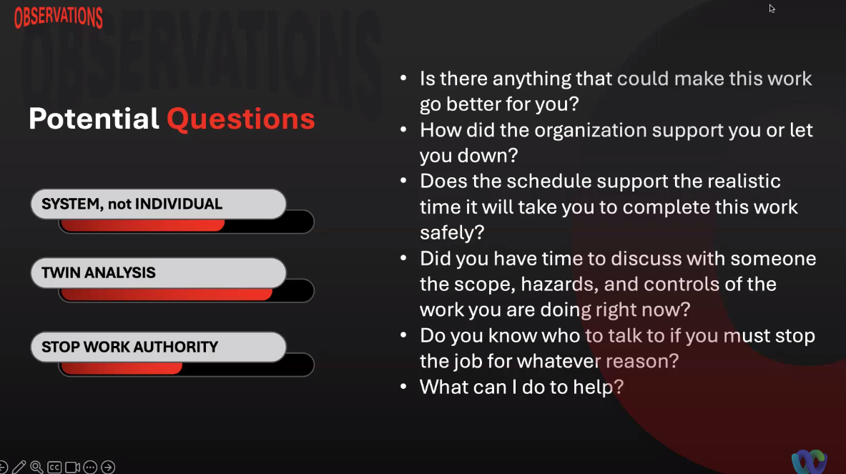
James covered a list of potential questions:
- Barbara Jesus asked if anyone has used the 4Ds - What do we do that is dumb, different, difficult, or dangerous?
- Mike Petrowski suggested, when hearing issues and concerns, be careful not to "take the monkey". Instead teach them to fish. IF asked: how do I get the trash emptied. If you take that monkey, you trained them how to get the trash emptied. Instead, educate them on who to contact to get the trash emptied.
- Barbara Jesus added that she has heard managers ask - how can I remove obstacles? or What can I do to make your job easier? By asking this way you invite them to share but you are not volunteering to fix it for them...
James asked the group if anyone involved with HPI is also involved with the Safety Culture Community of Practice. Several responded that they do integrate culture with their HPI duties.
- Harri Emari asked the group to share more information about it, as he is interested in organizational culture and safety culture.

- Community of Practice Business
- Review/Update Tasks and initiatives.
  - ISM-HPI-24-01 - Support DOE with the revision of HPI DOE-HDBK-2009-1028
  - ISM-HPI-24-02 - Support CAS WG with EFCOG SAFETY SUBGROUP ISM/CAS/QA TASK 3 - Establishing a consistent approach to addressing improvement in operational performance.
    - COMPLETE
  - ISM-HPI-24-02 - Support Office of ES&H Reporting & Analysis, EHSS-23, with Revision of DOE-STD-1197- Occurrence Reporting Causal Analysis
    - COMPLETE
- Announcements
  - New Team members
Levi Gesell
Site Services / Contractor Assurance Group
Conduct of Operations / HPI
704-1N, G39
Savannah River Site
Work Cell (839)746-3615
  - EFCOG Spring 2024 QA/ISM/CAS Joint meeting.
  - HPI Learning and Networking opportunities.
Human Performance
Activity(s)  ISM-HPI-24-01 | Benefit(s) | Deliverable/Key Milestone(s)
Support EHSS-20 revision of DOE-HDBK-1028-2009, Human Performance Improvement Handbook | Human Performance Tools for Individuals,  Work Teams, and Management were written in June 2009. They have become the core reference documents for many users both within and outside the DOE complex. These updates will help expand the scope of the Department's HPI programs by encompassing Human and Organizational Performance (HOP)  This effort will result in significant revisions to the Handbooks, with an estimated twenty-five percent change to Volume 1 and a fifty percent change to Volume 2. The content and the approach to the topics will be based on concepts and practices found helpful in the commercial nuclear power industry, electrical grid and distribution, national laboratories, and those adopted by other sectors. | The EFCOG HPI Task Team will collaborate with EHSS-20 to select EFCOG team members.  EHSS-20 will identify the specific updates that will be made by the team revising the Handbooks. The team will be composed of a Federal Project Lead with academic and technical experts. Team members will include subject-matter experts from DOE M&O contractors and thought leaders from outside the DOE complex.
Task 23-01 update:
- Finalized Second Drafts have been submitted.
- Now in the resolving phase – next meeting is TBD.
- If you have any questions, please email Rizwan Shah rizwan.shah@hq.doe.gov
- Riz Shah shared they’re still waiting on one group to submit changes; hope to have a draft copy in mid- to late-May, then enter into DOE’s review and comment process June 1.

Status Update:

- Upcoming Meetings and Conferences (EFCOG and other HPI meetings)
  - EFCOG Spring 2024 QA/ISM/CAS Joint meeting
    - May 6-9, 2024
    - INL hosting
    - HPI CoP will be virtual (TEAMS) 12:00 to 4:00 EST
    - Registration now open (https://efcog.org/qa-ism-cas-communities-of-practice-operational-meeting-event-website/ ) and agenda coming soon.
    - Call for presenters.
      - Susan Blackburn, ORNL: Chemical Safety Through the Lens of HPI
      - Jay Poole ORNL: Incorporating Human Performance Defenses Following Outages
      - Rizwan Shah, DOE-HQ, Task 23-1 update DOE-HDBK-1028-2009 revision status update
      - Open for others to present or suggest presentations (Tamara Shokes has an idea for an additional presenter)
      - James Newman suggested Charles Duhigg, book is “Super Communicators” and it is a great book
      - Barbara Jesus offered to do a short presentation on the 4D’s
      - Ken Madson asked if there would be an opportunity to have Psychological Safety presented
    - Mike reviewed the draft agenda for the week’s currently planned activities
  - Human Performance In Action (HPAC)
    - April 15th-17th, 2024 at Harrah's New Orleans Hotel!
    - https://www.humanperformanceinaction.com/
    - Registration details: https://www.humanperformanceinaction.com/learn-more
  - Community of Human and Organizational Learning (CHOL)
    - 2024 Conference:
      - June 11-13, 2024 | Workshops June 10 & 14, 2024
      - Hilton Lake Las Vegas, Henderson, NV
      - Event website: https://www.cholearning.org/2024learningconference
      - Buy Tickets: https://www.eventbrite.com/e/impact-2024-cholearning-30th-annual-conference-registration-771675250447?aff=Website
    - YouTube Channel: https://www.youtube.com/channel/UCRbkD3m2ro7kCK-uF1X772A
      - NOTE: 2023 presentations may be found here
- Webinars: still the same
  - EUCI - Human Performance Community of Practice
    - https://www.resilientgrid.com/hpcop
    - Hosted by KnowledgeVine
    - Next meeting is April 25
    - HP Community of Practice discussions will continue to take place every third Thursday and are free for the HP community to participate. There will be a presentation and discussion by a few select hosts, followed by a question and answer/discussion period for all. We will follow up on the session with a virtual Happy Hour.
    - To join: https://mailchi.mp/e4274b7f9e84/hpcop
    - HumanPerformanceCOP@gmail.com
    - Past Presentations: https://www.resilientgrid.com/hpcop-3
  - CHOL - Community of Human and Organizational Learning
    - https://www.cholearning.org/
      - Formerly HPRCT - https://hprct.org redirects you to the new webpage
    - Events: https://www.cholearning.org/professional-development
    - NEWS: The latest from the Community: https://www.cholearning.org/news
    - Video Library on YouTube Channel: https://www.youtube.com/channel/UCRbkD3m2ro7kCK-uF1X772A
    - Community Resources: Your first stop in organizational learning materials! https://www.cholearning.org/community-resources
    - Our online interactive forum is now LIVE! Check-in back daily for insider access to Conference insights.
      - https://www.cholearning.org/askthecommunity
- PodCasts:
  - Pre-accident Investigation Podcast w Todd Conklin
  - The Safety of Work w David Provan
  - A HOP Podcast with No Name w Adrea Baker and Matt Florio
  - Health and Safety Conversations w Tim Bourne
  - Safety on Tap w Adrew Barrett
  - The HOP Nerd w Sam Goodman
  - Safety Labs w SLICE
  - Leading Safely Podcast w Georgina Poole
  - Rebranding Safety w James MacPherson 10. Psych Health and Safety w Peter Kelly
  - Amy Edmondson: How To Fail Well
3) Round Table (Those who provided updates)
- Mike Petrowski (LANL) – more learning teams, getting some good traction since they moved to facilitator orientation; getting a lot of good information from the teams to share in their Lessons Learned system
- Ken Madson
- Valerie Slusher (INL)
- Lauri Minton (CNS, Pantex) – working through new management/reorganization.
- James Newman (LBNL) – they are going forward with Learning Teams; finalizing their informal approach; appreciates Benjamin Close and his team at Sandia helping each other out with Learning Teams as the focus; management just selected him as the Safety Culture chair at Lawrence Berkely; was wondering if a lot of HPI people overlap into safety culture; several on the call do.
- Linda Flores – NA
- Barbara Jesus (LLNL) – doing some introductory training to HOP training
- Eric Schlatter (FNAL) – nothing to report
- Deb Miller (FNAL) – nothing to report
- Tim Snow (NREL) – nothing earth shattering; asked Barbara if she can email him the providers they are using for the training
- Valerie Slusher (INL) – she will email Mike her idea for a presentation; no other updates at this time
- Becca Swaner (INL) – NA
- Becca Swaner (INL) – NA
- Andre Layson (ICP) – nothing to report
- Saprina Lyons (ICP) – NA
- Amanda Jimenez (SPA) – if anyone is interested, their presentation on FRAME (formally known as HCE)
- Katrina Rocha (NNSS) – NA
- Wes Drnek (NNSS) – nothing to share
- Bill Brown (BNL) – Bill Brown (BNL) was contacted by someone developing ConOps training for BNL’s Utilities staff. The ‘ask’ was for help in selecting a 3-5 minute video on HPI to include in the ConOps training (insert eye-roll emoji here). Bill will be reaching out to people who have explored how ConOps relates to HPI (i.e., they both support reliable human performance). Anyone having any experience or materials along those lines, please get in touch with Bill.
- Roby Robinson (Hanford) –
- Susan Blackburn (ORNL) – at the end of April (29 – May 3) is Safety Fest Tennessee 2024, it’s been going on for a few years; it’s all free, various training, seems to be quite a few people from HPI/HOP going to speak; the link is https://safetyfesttn.org/ and Joe Estey is one of the speakers this year
- Ben Close (SNL) – effort to stand up learning teams; they’ve been trying to set them up, and to help support the pockets of learning teams, they are having a routine meeting and also inviting several outside labs to participate; they’re also working on a Sandia-wide approach; they are working on “Active Monitoring,” and having psychologically safe conversations with teams, using the 4 D’s – one group came up with two more – what is Deficient, and Distracting – to help managers do the active monitoring conversations
- Linda Flores (SNL – NA
- Valerie Webb Cline (SNL) – NA
- Hari Emari (SLAC) – nothing major; they have organizational changes at SLAC, Contractor Assurance/Contract Management – there are some opportunities if you are interested, reach out to him; would like to learn more about safety culture groups, please reach out to him at emari@slac.stanford.edu
- Riz Shah – nothing else to report
4) Closing
Mike thanked everyone for participating. Next conference call is April 25.

EFCOG meeting first week of May

Meeting concluded at 12:20 CST

