OVERVIEW
Certain English words, though correct, are rarely used in business writing. For instance:

Word | Misspelling of…
Archrival | Archival
Incontinence | Inconvenience
Manger | Manager
Pogrom | Program
Tem | Team
See page 4 for a more extensive list of words you might want to remove.

To ensure that a word is automatically marked as a spelling error, you can remove it from MS Word’s spell check dictionary.

STEPS FOR REMOVING WORDS FROM SPELL CHECK
Winkey
- Open Microsoft Windows Explorer (Computer), by clicking the Winkey+E.

- On the menu bar, click File, then select Change folder and search options.

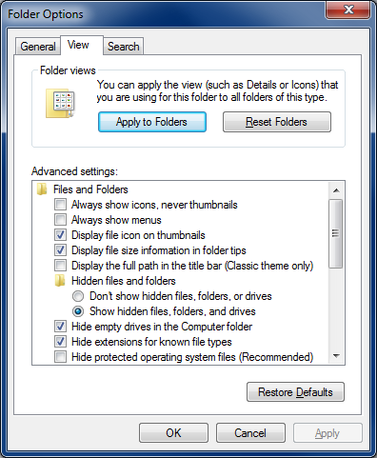
- Click the View tab of the dialog.

- In the Files and Folders section, under Hidden files and folders, click the button for Show hidden files and folders.

- Uncheck Hide protected operating system files (Recommended).

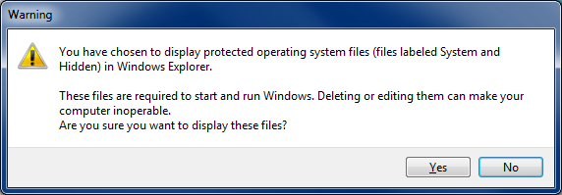
- Click Yes when you receive the error message.

- Navigate to C:\Users\(your user name) \AppData\Roaming\Microsoft\UProof\ExcludeDictionaryEN0409.

- Right-click the file entitled ExcludeDictionaryEN0409, select Open with… and More apps.

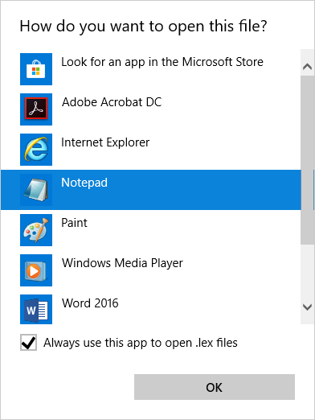
- Select Notepad, and click OK.

- Type the words that you want the spell checker to flag as misspelled. Be sure to type the words in all lowercase letters, and press ENTER after each word.

- Save and close the file.

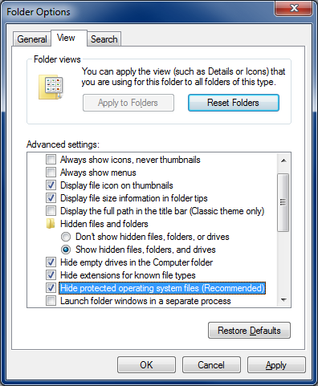
- If you want to make it easy to open and edit the file (e.g., add new words to it), create a shortcut to it (and place it on your Desktop or other easy-to-remember location).

- Go back into Folder Options (see steps 1-3), and in the Files and Folders section, recheck Hide protected operating system files (Recommended).

WORDS YOU MIGHT WANT TO REMOVE
abut | dame | hooter | mod | resent | surrey
anus | ding | hot | moth | retard | survive
angel | don | implant | mow | rook | swill
archrival | erotic | implanted | mush | rouge | sword
ass | eternal | implantation | nest | sand | swords
asses | ewe | incontinence | newt | shed | tam
ax | fat | indict | nude | sift | tat
ay | filament | indicted | orgies | sin | tem
bane | fin | indicting | overnight | sing | theism
bank | flies | jut | pleas | sinister | theological
beings | form | lace | pogrom | snot | theses
bing | freer | loner | poplar | son | tile
bout | fro | lust | posed | sot | tiles
brining | god | manger | pout | sots | till
ca | greed | mangers | provider | sow | tot
casual | heath | mater | pubic | spit | ward
cos | hell | meat | realloy | star | wed
coy | hem | mete | repot | supper
daft | hen | meting | requiem | supplicate

