

Guidance for Development, Review, Approval, and Posting of White Paper Documents

**Purpose:**

Establish guidance for the development, review, approval and posting of white papers within the Energy Facility Contractor’s Group (EFCOG) website.

**Background / Scope:**

Currently within EFCOG, there is a defined process for the development, review, approval and posting of “Best Practice” documents. These documents are intended to communicate initiatives that are innovative and represent actions beyond generally accepted standards or application of standards. Their intent is to increase the efficiency and effectiveness of known practices across the various DOE complexes. In addition to a “Best Practice” (BP), there may be a need within an EFCOG sub group or task group to develop a “White Paper” (WP). A WP is basically a document that contains additional or enhanced information about a specific topic area or practice. It may expound on current known practices, however, it does not establish requirements. It should not be treated as a BP although it may evolve into a BP provided it complies with the EFCOG criteria for a BP. (See EFCOG site for BP requirements)

Time and effort are put into the development of WP documents. These documents may contain information of value to a specific sub group or task group so it would be of benefit to post these documents to the EFCOG library where others may also find the information to be of value.

**Definition:**

White Paper: An informational document that is issued to promote or highlight a specific topic. It is intended to assist readers, using facts and logic, to understand an issue, solve a problem, or assist with decision making.

**Development:**

The WP generally initiates through the Chairperson within an EFCOG subgroup or task group. The topic is identified, and a WP Lead is selected by the group Chairperson. Persons may also volunteer to be the Lead. The WP Lead with support from the Chairperson develop an expectation for the papers result.

The WP should generally be short and brief (<10 pages), but depending on the scope and breadth taken by the Lead, it could exceed 10 pages.

The WP should be structured as follows: (See Attachment A for an example)

* Cover page (contains; title, document number, place for name of WP Lead, and Chairperson approval)
* Table of Contents (At WP Lead discretion)
* Summary (Also include name/company of any supporting contributors)
* Purpose
* Scope (may also include a background statement)
* Definitions
* Narrative
* Conclusion
* References

Numbering for the WP, should be as follows:

WP – Cal. Year – Working Group – Sub Group – Task Group – Seq. Number

See ATTACHMENT B for a listing of Working Groups/Subgroups/Task Groups and their abbreviations to use for the report number.

The sequence number is based on the calendar year and the group that released it. If the WP was initiated by the Subgroup, then insert “000” for the Task Group and vice-versa.

So, if the Policy and Procedures Task Group initiated two WP’s for 2019 it would look like: WP-2019-SAF-000-PP-001 and WP-2019-SAF-000-PP-002. If the Physical Protection Subgroup released a WP it would look like WP-2019-SS-PPR-000-001. The sequence number for all groups would revert back to 001 at the start of a new calendar year.

The EFCOP Web Page Administrator shall maintain the list of released WP’s.

**White Paper Review:**

Once the WP has been prepared, submit a DRAFT to the Chairperson who will release it to other group members for review and comment. The Chairperson defines the review and comment period (should not exceed 30 days). The Lead resolves all comments. The Lead presents the final DRAFT at the next scheduled EFCOG meeting. The Lead incorporates any last minute comments and submits to Chairperson for approval.

**Approval/Posting:**

The WP is presented by the Lead at the next scheduled EFCOG group meeting to affirm that the WP is complete and all comments have been addressed. A vote is taken within the respective Subgroup or Task Group. If accepted, then the Chairperson and Lead print, sign and date to approve the WP. Papers that originate in the Subgroup are approved by that respective Chairperson and similar for those papers that originate at the Task Group level. The Chairperson shall forward the WP to the EFCOG web page administrator for upload/posting to the WP file within the EFCOG library.

ATTACHMENT A

WP FORMAT EXAMPLE

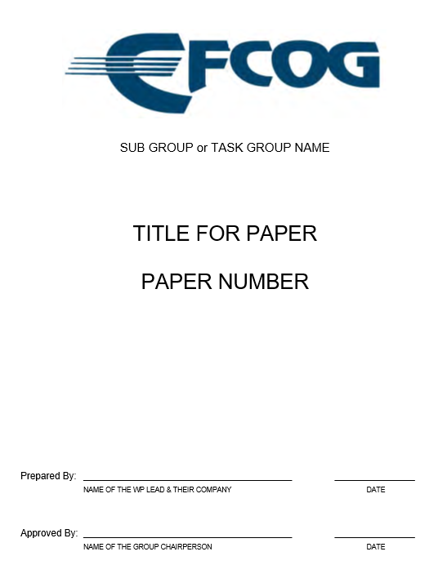

**TABLE OF CONTENTS (IF NECESSARY)**

**SUMMARY:**

Provide a summary of the papers key points or observations

Include a list of any supporting paper contributors and their company name

**PURPOSE:**

What was the purpose for developing the WP.

**SCOPE:**

What was the bounding area that you focused on? This may also include a background statement.

**DEFINITIONS:**

Include if applicable. Otherwise enter “NONE.”

**NARRATIVE:**

Describe what you examined, evaluated or observed.

**CONCLUSION:**

Try to summarize your results in one paragraph, but if necessary, then no more than two.

**REFERENCES:**

Just list them, or enter “NONE.”

ATTACHMENT B

WORKING GROUP / SUB GROUP / TASK GROUP ABBREVIATIONS

|  |  |
| --- | --- |
| WORKING GROUP | ABBREV. |
| Project Delivery | PD |
| Safeguards & Security | SS |
| Safety | SAF |
| Training | TRN |
| Waste Management | WM |

|  |  |  |  |  |
| --- | --- | --- | --- | --- |
| SUB GROUP | ABBREV. |  | TASK GROUP | ABBREV. |
| Acquisitions & Contracts | AC |  |  |  |
|  |  |  |  |  |
| Project Controls | PC |  | Earned Value Management | EVM |
|  |  |  | Scheduling | SCH |
|  |  |  |  |  |
| Project Management | PM |  | Cost Estimating | CE |
|  |  |  | Project Review Peer Support | PRPS |
|  |  |  | Risk Management | RM |
|  |  |  |  |  |
| Startup, Testing & Commissioning | STC |  |  |  |
|  |  |  |  |  |
| Information and Security | IS |  |  |  |
|  |  |  |  |  |
| Material Control & Accountability | MCA |  |  |  |
|  |  |  |  |  |
| Physical Protection | PPR |  |  |  |
|  |  |  |  |  |
| Program Planning & Management | PPM |  |  |  |
|  |  |  |  |  |
| Engineering Practices | EP |  | Fire Protection | FP |
|  |  |  | Welding | W |
|  |  |  |  |  |
| Integrated Safety Management | ISM |  | Contractor Assurance System | CAS |
|  |  |  | Human Performance Improvement | HPI |
|  |  |  | Occurrence Reporting | OR |
|  |  |  | Safety Culture/High Reliability Org. | SCHRO |
|  |  |  | Work Management | WM |
|  |  |  |  |  |
| Nuclear & Facility Safety | NFS |  | Accident Analysis | AA |
|  |  |  | Criticality Safety | CS |
|  |  |  | Nuclear Safety Research & Dev. | NSRD |
|  |  |  | Safety Basis | SB |
|  |  |  | Unreviewed Safety Questions | USQ |
|  |  |  |  |  |
| Quality Assurance | QA |  | Policy & Procedures | PP |
|  |  |  | Software Quality Assurance | SQA |
|  |  |  | Supply Chain Quality | SCQ |
|  |  |  |  |  |
| Regulatory & Enforcement | RE |  |  |  |
|  |  |  |  |  |
| Sustainability & Environment | SE |  |  |  |
|  |  |  |  |  |
| Worker Safety & Health | WSH |  | Electrical Safety | ES |
|  |  |  | Industrial Hygiene & Safety | HIS |
|  |  |  | Laser Safety | LS |
|  |  |  | Occupational Medicine | OM |
|  |  |  | Radiation Protection | RP |
|  |  |  |  |  |
| Training | TRN |  | Learning Management System | LMS |
|  |  |  | Regulatory Affairs | RA |
|  |  |  |  |  |
| Waste Management | WM |  | Decontamination & Decommissioning | DD |
|  |  |  | National Laboratory | NL |
|  |  |  | Packaging & Transportation | PT |
|  |  |  | High Level Waste | HLW |

Where no Task Group exists for a given Subgroup, then that block is shaded.