**Implementing an RFID System for Chemical Management**

*This document does not create any new or additional requirements.*

**Abstract**

Radio Frequency Identification (RFID) technology has been gaining attention as a method for improving asset management across a variety of industries. Several DOE sites have successfully adapted the technology for managing chemical inventories. The intent of this document is to share the lessons learned in implementing RFID specifically for managing chemical inventories. Chemical inventory management has some unique considerations when applying RFID technology. Ideally, a limited number of tag configurations are desired yet chemical containers come in many forms. In addition, chemicals are stored in a variety of environments that impact tag options. Conducting chemical inventory reconciliation is a tedious task but it is essential for various chemical management and regulatory compliance functions. RFID has demonstrated promise for drastically reducing the time required to perform chemical inventories and offers desirable features to aid in other facets of chemical management. RFID reduces potential chemical and ergonomic hazards associated with traditional forms of chemical inventory activities by reducing contact with chemical containers and access hazards.

**Background**

Chemicals are stored in a variety of conditions and configurations including indoors, outdoors, above or below ambient temperatures, cabinets, enclosures, shelves, benchtops, over packaging, glove boxes, hoods, etc. Adapting RFID to chemical management requires some trial and error to be successful. Standard RFID configurations studied for chemical management have included fixed or portable readers and primarily passive RFID tags. The use of passive tags versus active tags (embedded power supply) is primarily to address the economic delta between tag cost and asset value. The cost of active tags is generally not justified for standard chemical management inventory functions. As the technology has been tested through various chemical storage scenarios, the DOE complex has focused toward passive tags coupled with mobile readers as the primary solution for managing chemical inventories. RFID has inherent features that are not available with traditional barcode or other asset management technology. For example, since RFID is proximity based, the technology can be used to locate assets by programming a notification into the reader as the user gets closer to the desired item.

**Acronyms and Abbreviations**

**Active Tag:** Active RFID tags have a transmitter and their own power source (typically a battery).

**EFCOG:** Energy Facility Contractors Group

**EPC:** Electronic Product Code

**EPC Gen2:** Electronic Product Code Global UHF Class 1 Generation 2

**IHSTG:** Industrial Hygiene and Safety Task Group. A group within the EFCOG Worker Safety & Health Sub Group

**Passive Tag:** Passive RFID tags are powered by the electromagnetic energy transmitted from an RFID reader.

**Read Range:** The distance from which a reader can communicate with a tag

**RFID:** Radio Frequency Identification

**RFID Tag:** An RFID microchip attached to an antenna and mounted on a substrate

**Acknowledgements**

This DOE document was prepared under the sponsorship of the EFCOG Worker Safety & Health Sub Group (WS&HSG) and the DOE EFCOG Liaison. An EFCOG RFID Task Team was formed within the Industrial Hygiene & Safety Task Group (IHSTG) to develop this document. The IHSTG would like to acknowledge the following specific RFID Task Team members who authored the various chapters of this document.

RFID Task Team Members:

Jeff Sickau, (Team Lead) Oak Ridge National Laboratory (ORNL)

Judi Johannesen, Pacific Northwest National Laboratory (PNNL)

Jeff Hieb, AECOM-Hanford

Bob Petricek, Brookhaven National Laboratory (BNL) (Retired)

To aid in the development of this document a Chemical Management RFID Benchmarking Questionnaire was sent out to the EFCOG members and ORISE members to obtain information on RFID programs at their facilities. We would like to gratefully acknowledge the many individuals who have helped with this effort.

Dan Best, Lawrence Berkeley National Laboratory (LBNL)

Mark Kidd, Savannah River National Laboratory (SRNL)

Fred Simmons, Savannah River Site (SRS)

Greg Lee, Lawrence Livermore National Laboratory (LLNL)

Julie Sager, Ames Lab

Mark Brynildson, Sandia National Laboratory (SNL)

Mark Hermanson, Mission Support Alliance-Hanford (MSA-Hanford)

Kevin Allgeyer, Kansas City Plant-Oak Ridge Institute for Science and Education (KCP-ORISE)

Radesh Mohan, Argonne-ORISE

**Chapter 1 - RFID Technology Overview**

**1.1 Introduction**

RFID utilizes radio frequencies to communicate between a reader and an RFID tag. RFID tags are applied to assets similar to a barcode. RFID tags can be custom printed and encoded by RFID capable printers. Tags can also be encoded / edited with RFID readers. When conducting an inventory reconciliation, the reader sends a radio signal to the tag and interrogates the coded tag for identifying information. The signal is then returned to the reader to positively identify an item. This is visually similar to the laser used for barcode scanning but rather radio frequency is used instead of the laser to retrieve identifying information. The benefit of using RFID over barcode technology is that the barcode must be visibly identified and aligned with the scanning device whereas an RFID tag generally just needs to be in proximity to the reader. The distance required between RFID tag and reader is generally determined by tag and reader configuration and chemical storage conditions.

**Benefits of RFID Technology for Managing Chemical Inventories**

RFID helps to address the constant desire to perform chemical inventory functions as efficiently and safely as possible. RFID has proven to accomplish this for managing chemical inventories and holds promise for many other DOE inventory or security applications.

* Chemical inventory accuracy can be increased by allowing more frequent chemical inventory reconciliations due to the reduced time required for each reconciliation effort. For example, some facilities have increased inventory reconciliation frequency to annually rather than every three years due to the time savings offered by RFID.
* RFID technology can be used to locate chemicals quickly in a laboratory eliminating time used to search for a chemical, can potentially eliminate the purchase of replacement chemicals and can potentially save on the cost of waste disposal for the additional purchase of replacement chemicals not used.
* RFID technology can be used to efficiently locate highly hazard chemicals for inspection, testing and safe storage
* RFID technology can be easily used to inventory chemicals in glove boxes, desiccators and refrigerators.

Managing chemical inventories utilizing RFID technology has proven to substantially reduce the time required to reconcile inventory while reducing extensive handling of containers to conduct other forms of inventory reconciliations. The table below illustrates the efficiency and costs savings of using RFID to manage chemical inventories at Oak Ridge National Laboratory (ORNL). Brookhaven National Laboratory (BNL) and Pacific Northwest National Laboratory (PNNL), among others, have realized similar time savings. For example, a room containing 1,000 chemical containers that took approximately 4 to 5 hours to scan with a barcode scanner now only takes 30 minutes to scan with an RFID scanner.

|  |  |  |
| --- | --- | --- |
| **Item** | **RFID** | **Barcode** |
| Time per area reconciled at ORNL | 1-2 hours | 8-10 hours |
| Time to annually reconcile ~1,300 storage areas at ORNL | 1,300 – 2,600 hours | 10,400 – 13,000 hours |
| Example cost assuming $65/man-hour | $84,500 - $169,000 | $676,000 - $845,000 |
| Potential Annual Labor Time Savings | 9,100 – 10,400 hours | N/A |
| Annual Labor Cost Savings | $591,500 – $676,000 | N/A |

**1.2 System Attributes**

**RFID for Managing Chemicals**

RFID is desirable for managing chemicals due to the inherent nature of the technology as compared to barcode or other asset management technology. Inventory items can be identified in a fraction of the time required by other methods. The realized benefits also include reduced container handling which prevents breakage and chemical exposure to physical or health hazards. RFID also reduces ergonomic hazards associated with moving containers and bending and climbing to access containers. The fact that RFID can be used to locate an asset is beneficial for finding chemicals of concern or locating a certain container in densely populated storage areas. A [video](https://www.youtube.com/watch?v=D7fX3nqHhGI) was created to demonstrate the efficiency of utilizing RFID as compared to barcode technology at ORNL. The video demonstrates the reduction in handling and movement of chemical containers described above.

**RFID System Hardware**

A basic RFID system is comprised of readers, tags and RFID capable printers. Printers are not necessarily required but are common for chemical management as other visually identifying information is traditionally printed on the face of the RFID capable label. The printers and readers interact with a facility’s chemical management system either through a docking station or wireless technology. Some site level customization is typical for all systems but the hardware types are fairly consistent and readily available. All tags have memory banks and pre-programmed unique identifiers written in a universal code (EPC Gen2). Facilities can either align the original tag identifier to their chemical container identifier or encode their chemical identifier onto the tag with a printer or reader. The latter generally involves more programming effort and possibly higher tag cost.

**RFID Tag Configuration**

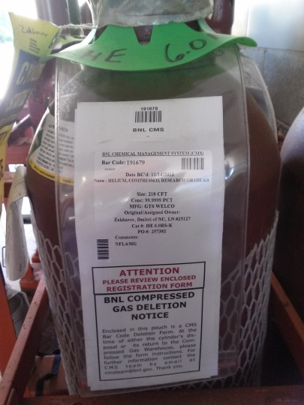Passive tags have become the normas various tags have been tested for chemical management. Passive tags better address the Return on Investment (ROI) cost delta for managing chemicals as relatively low value assets. It is understood that active tags could enhance functionality but are generally more expensive and usually larger than passive tags, thus making them cost and size prohibitive for chemical management. Additionally, there may be cyber security concerns at some facilities with the use of active tags. Passive tags are typically ordered in rolls and are commonly applied with an adhesive backing. In certain circumstances, tags cannot be applied directly to chemical containers so various solutions have been adapted. For example, smaller containers can be placed inside bags or larger containers and the tag can be applied to the outer packaging. Metal containers are known to interfere with RFID. Metal compatible tags can be purchased or existing tags can be modified to work better with metal. For example, on metal containers an insulating barrier, such as foam tape, can be placed between the tag and container. Cylinder pouches used to hold gas cylinder information can house the RFID tag to prevent metal interference. Configuring the label as a “flag” has also been found to be highly effective in eliminating interference from the container or material within the container.

Figure Cylinder Pouch

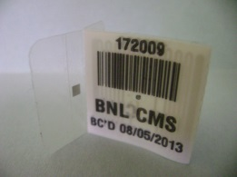“Flag” tags or tent labels, in general, have shown promise for applying to all forms of chemical containers. A flag tag is basically a folded adhesive label where a tab is formed protruding out from the container. The RFID label and antenna are applied on the tab surface to help isolate the tag from container interference. A flag tag with a clear adhesive base is desirable for not obstructing the chemical manufacturer label. Minimizing obstruction of manufacturer labeling with any inventory technology is an important factor for hazard communication compliance purposes. The flag tag configuration can be adapted for barcode based inventory systems as well.

Figure Flag Tag

**Placement of RFID Tags on Chemical Containers**

Tags read more effectively if placed on chemical containers in certain ways. Tags are generally most effective if placed in line of sight and near the top of containers. Studies on chemical containers at BNL have shown the label attenuates best if placed above the contents of the container.

Providing written information on the best label placement method can prevent problems later. There are some common placement practices, but it will be better defined during a facility’s pilot testing of their system. Discussion points and pictures on how to apply RFID labels will aid in understanding the RFID label placement program for your facility and to help ensure placement consistency. Common key points on RFID label placement include placing label high on container, away from pour spout area of container and trying not to cover-up critical areas of the manufacturer’s label.

Examples of RFID label placement:

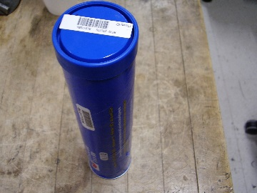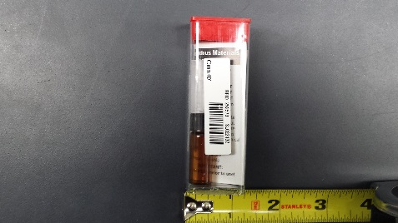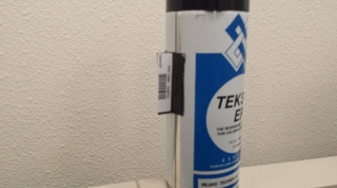

**RFID Capable Printers**

RFID capable printers are widely available. They vary from production to desktop versions. The printers are nearly identical to traditional label printers except that they feature an encoder to capture or program information into the RFID chip embedded in the label as the label is also printed with ink. Many facilities start with a production model printer for initial receipt of chemical containers and may deploy smaller desktop versions for satellite printing and label replacement functions. Printers can also be placed on carts to aid in transitioning existing barcode labeled containers to RFID capable labels in existing inventories.

**RFID Readers**

Readers come in two basic forms, fixed and mobile. The use of the technology differs depending on which type is chosen. A fixed reader requires that the inventory item pass through or near the fixed antenna field. This is commonly referred to as a portal. A mobile reader is brought to the location of the inventory and the containers generally remain undisturbed during reconciliation. Since chemical inventories are widespread in most facilities and generally do not pass through common portals, mobile readers have become the desired reader configuration. Fixed readers are still considered to have merit for chemical management. For example, fixed readers could be installed in the ceilings of labs to continuously monitor chemical inventories in real time rather than performing a scheduled reconciliation. The cost of fixed readers and infrastructure requirements has been prohibitive to this point for chemical management. Fixed reader costs are trending downward though and may offer promise as a solution for high density chemical storage areas in the future.

**Chapter 2 - RFID System Implementation**

**RFID System Considerations**

This section details the major considerations in implementing an RFID program for chemical inventory management. These sections are based on lessons learned from facilities that have either implemented or are in the process of implementing an RFID program for managing chemicals. There is some common consistency in implementation among facilities and some differences. The common themes are mobile readers, passive tags and printer types. The differences are commonly funding levels, re-labeling existing inventory vs only new inventory, inventory container types, label size and specifications, assigned user groups, training and internal documentation.

Implementing an RFID program encompasses a variety of choices from hardware to desired functions to interfaces with internal systems. A basic system will consist of RFID readers and tags. Limiting the varieties of tags and readers for one application is often times the desired solution. RFID capable printers are commonly used for chemical management but are not necessarily required for an RFID system. Pre-printed labels and/or pre-programmed tags and labels can be purchased and further programmed with existing readers in the absence of printers. A basic RFID system for chemical management normally includes passive tags, mobile readers and RFID capable printers that can both print traditional chemical label information and encode RFID tags imbedded in the label. Many sites also print barcodes or Quick Response (QR) codes on RFID capable labels. This allows the label to be captured with multiple technologies if needed.

**Obtain Funding for an RFID System**

Funding needs can vary depending on available facility resources, system functions, hardware involved and system interactions. RFID is more expensive up front than a barcode system but the investment is returned through increased efficiency. A basic RFID capable chemical reconciliation system comprised of mobile readers, passive tags, printers and software will start at around $30k. Once a system is established, ongoing annual non-labor costs are primarily tags and maintenance upgrades. Tag costs will vary by inventory turnover and chemical transaction volume. At ORNL, for example, approximately 25,000 tags per year are generated for newly purchased containers.

**Address Security Concerns and Misinformation**

Many of the security concerns associated with RFID come from a lack of understanding of what the technology can and cannot do within specific applications. For chemical inventory applications, a unique chemical identifier is likely the only information that will be encoded on the tag memory. This same identifier is likely printed on the label or available in the chemical management system. Chemical inventories, locations and hazards are generally disclosed to all employees who may be exposed to chemicals in order to address OSHA Hazard Communication requirements. Passive tags used for chemical management are only retrievable within a few feet of a tag with a reader. Passive tags also do not read well, if at all, through walls or closed solid doors such as flammable cabinet doors and refrigerator doors. The reader serves as the conduit between the captured tag information and the more detailed item information in the chemical management system. If tag programming is limited no useful security information could be obtained by retrieving a number from the tag without access to the chemical management system that the tag is related to. It is important to only write information to the tag that is necessary to manage the chemical inventories. There should be no need to write personal identity or location information to the actual tag. This information can be contained only in the chemical management system.

**Pilot Test the Proposed System**

The best approach is to start with a pilot test program during the development phase of a new RFID program. Many DOE sites have already been through this phase and willingly offer guidance on best practices and applications. Every site has slightly different chemical management practices so some site level customization will exist. A pilot scale system will allow developers and users to easily troubleshoot and make changes necessary prior to full scale deployment. For chemicals, it is best to try several reader and tag configurations in small representative storage scenarios. Most sites try to replicate the size and shape of existing chemical inventory labels with RFID capable labels. Once the pilot test is successful the system can be scaled up to full production mode.

**Train Users of the System**

RFID manufacturers have detailed manuals on the operation of their equipment. If the manuals are not inclusive enough, then creation of an in-house document may be warranted. Being descriptive on the steps needed and adding pictures on sections of the operational steps can aid with understanding and use of the new program. Site level custom features and functions of the system should be covered as well.

**Retroactive Labeling of Inventory vs. Point Forward Labeling of New Items Only**

A key decision in implementing an RFID system is whether to retroactively label existing inventory or label only new inventory from a certain date forward. Labeling may also be phased in by building, facility or division. This decision factors heavily into start-up funding needs. Retroactive labeling will require procuring tags for existing inventory up front. For example, if a facility has 50,000 items in existing inventory and purchases another 10,000 items each year they will need to budget for enough tags and ink to generate the initial 50,000 labels as well as the 10,000 additional labels for new purchases. Labels generally cost $0.10-$0.40 each so ~$7,000 - $26,000 should be allocated for tags and ink costs if printing labels. Pre-printed labels are available as well. The time and effort involved in labeling existing inventory must also be considered. Many facilities retroactively label by conducting traditional reconciliations and apply RFID capable labels as they conduct the reconciliation. It is very helpful to have a mobile platform for this effort. A mobile platform typically includes a cart containing RFID labels, an RFID capable printer and laptop or tablet to interface with the chemical management system. This allows the user to move the labeling equipment between chemical storage locations. Another option is to print labels by storage location and apply them in the field. A reconciliation should be conducted first to avoid unnecessary or inaccurate label generation. This effort is also a great opportunity to purge unnecessary chemical inventory before adapting it to RFID.

**Deploying the System**

At this phase the system should be thoroughly tested and proven to work as desired. All stakeholders should be on-board as well. Decisions on system hardware, training and process flow should be established. The final production phase should have considered all aspects of chemical inventory management at the facility. This includes:

* Communication of label functions and any system changes.
* Security and safety concerns with RFID addressed.
* Information Technology authorizing and supporting the applications and hardware being used.
* Who will perform labeling of containers and where. This is probably similar to the existing protocol.
* How to request new labels or adding labels for existing inventory. Many times, users will request labels for existing inventory after they realize the time savings of RFID. Determine who will pay for and provide those labels.
* Users should be trained on the various system hardware and software to perform reconciliations, apply labels, print labels, best scanning methods, best tag placement, etc.
* Disposing of items with RFID labels. Provide guidance on whether to dispose of labels with the container or remove labels to scan for disposition later.

**RFID Development Lessons Learned**

* + - Consider adding to the RFID scanner a find and seek feature when creating a new RFID program.
    - Placement of tags and how the container is stored can affect how well the RFID tag will operate.
    - Some potential exists that scanners can read containers in adjacent storage areas. Crosstalk through walls can be reduced by reviewing what is on the other side of walls before starting a scan, lowering the power level of the reader and limiting the use of the scanner near walls where there are no chemicals and it is known that chemicals exist on the opposite side of the wall. Research if a EMR shielding paint can be used to reduce or eliminate crosstalk. Note that this may also reduce the signal strength of Wi-Fi in the area.