
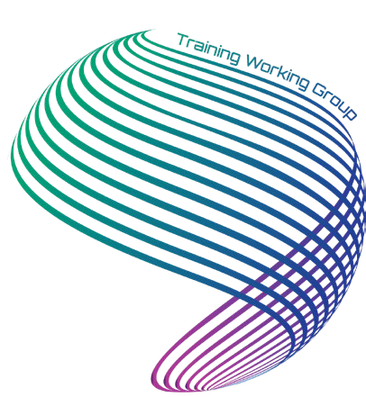
Call for Presenters and Panel Members 2026 Training Working Group Annual Meeting
Hosted by: Oak Ridge National Laboratory
Conference Dates: March 17 - 19, 2026
Oak Ridge, Tennessee USA

We are seeking dynamic, engaging, and knowledgeable presenters and panel members for the 2026 Training Working Group Annual Meeting.

AUDIENCE:
The conference audience consists primarily of training professionals, from entry-level contributors to senior level management from the Department of Energy (DOE) facilities and projects.

CRITERIA:
Proposals should be for a 45-minute presentation that is interactive, creative, dynamic, and features best practices. The presentation can be for a general session, breakout session, or workshop. The presentation timeframe includes introductions, presentation material, and a question-and-answer session. Attendees should leave with specific knowledge and skills related to the topic and with motivation to apply it to their daily work activities. Presentations should refrain from promoting a specific business, product, or service. Group sessions, breakout sessions, and workshop content should be geared to a level that is appropriate for the target audience.

SESSION FORMATS:
A variety of presentation formats are desirable at the conference and may include lecture format, panel presentation, or roundtable discussions. Handouts may be appropriate, depending on the complexity of the topic. Presenters are responsible for providing copies of handouts and any equipment that will be used during the presentation, including laptops or iPads. We strongly encourage speakers to use proven adult learning techniques that engage adult learners. As able, encourage participation through discussions, case studies, and hands-on activities.

Although the meeting offers virtual attendance, in-person speaker attendance is preferred.

ABOUT EFCOG:
The EFCOG Training Working Group (TWG) is chartered to leverage the training and development expertise and experience of contractors to the U.S. Department of Energy (DOE). The purpose of the TWG is to ensure complex wide collaboration and integration to attain and maintain the highest levels of training, reduce redundant training, and assist in improving performance in the operation of DOE facilities and projects.

POSSIBLE TOPICS (Identified from our 2026 Annual Meeting Survey):
Artificial Intelligence (AI) & Technology Integration:
- Using AI for training development and workflows
- AI safety, ethics, and governance
- FedRAMP-approved tools, VR/AR, and platforms
- Section 508 accessibility in digital training
Training Evaluation & Effectiveness:
- Level 3 and Level 4 evaluation methods
- Measuring training impact and ROI
- Practical data collection strategies
- Evaluation for continuous improvement
On-the-Job Training (OJT) & Competency-Based Training:
- Formal OJT for high-hazard work
- Competency-based versus compliance-based training
- Skills assessment and qualification
- Knowledge transfer to new hires
Organizational Collaboration & Standardization:
- Cross-site collaboration and sharing
- Consistent interpretation of DOE requirements
- Standardized tools and processes
- Reducing duplication across organizations
Resource & Staffing Constraints:
- Operating with limited budgets and staff
- Space and scheduling challenges
- Modernizing legacy training systems
- Reducing manual workload
Leadership and Management Development:
- Successful programs or courses
- Managing change and resistance
- Multigenerational workforce leadership
- Building mentorship pipelines
Training and Delivery
- Engaging, scenario-based training design
- Modern delivery methods and modalities
- Digital records and delivery modernization
- Improving compliance training effectiveness
Knowledge Retention & Workforce Development
- Capturing institutional knowledge
- Early-career development strategies
- Career pathways and retention
- Workforce readiness for future missions
Multigenerational Learning & Engagement:
- Design techniques that accommodate different learning styles and preferences
- Engagement strategies across generations
Integrating training and admin systems
- Improving records management
- Increasing operational efficiency
- Best practices to reduce manual processes and increase automation

If you have a topic and it is not on the list, we encourage you to submit your idea for consideration.

KEY DATES:
  - Presentation request (attached form): ASAP
  - Professional Biography and Abstract Submission Date: January 30, 2026
  - Full Presentation Due: February 27, 2026 (Preferred format is Microsoft Power Point)

Note: Follow your public release policy for all presentations and materials.
If you are willing to support this event as a speaker, please complete the form below:

Full Name:
Business Title:
DOE Organization:
Contractor/Company:
City/State
(traveling from):
Business Email:
Mobile Phone:
Presentation Title:
Presentation Abstract

Please send completed form to slatercw@ornl.gov. Thank you!

